Infra Optimization – EasyPay

By Manuel Canelon

Contents

Creating EasyPay through Spring IO and creating Docker Image of App 5

Generating EasyPay Application from Spring IO (Java Project) 5

Unzipping ‘docker-spring-boot.zip’ file Generated by Spring IO 5

Checking that the ‘docker-spring-boot.zip’ was successfully extracted and copying the contents to the home directory as a folder called ‘docker-spring-boot’ 6

Going to Project’s src/main/java/com/EasyPay/dockerspringboot and create a new folder called ‘resource’ 6

Creating HelloResource.java file 6

Modifying the pom.xml file within the root directory of the project to assign a filename to the .jar file when we run Maven Install 7

Running mvn install in project’s root folder and showing a successful build 7

Checking new ‘target’ folder created after running mvn install and making sure there is a **docker-spring-boot.jar** file within the directory 8

Dockerizing EasyPay Application 8

Creating Dockerfile in project’s root directory 8

Creating DockerHub repository for Project 9

Building Image tagging the image as per the DockerHub repository 9

Testing Docker Image 10

Confirming that I can access **localhost:8085/rest/docker/hello** to show message from HelloResource.java 10

Checking all containers, we see our container which was stopped about a minute ago 10

Pushing the Docker Image to DockerHub 10

Confirming that the Docker Image is now visible in DockerHub repository 11

Creating EC2 instances through Ansible 11

Creating a KeyPair in AWS 11

Creating Ansible Playbook **EC2_Launcher.yml** to provision 3 EC2 instances using webserver key 12

Adding AWS Credentials to .boto file to allow Ansible to connect to AWS IAM Account 12

Running Ansible Playbook **EC2_Launcher.yml** 12

Checking AWS to make sure that 3 EC2 instances are initialized 13

Making sure the 3 EC2 instances are created successfully and in Running state 13

Assigning Master, Node1, Node2 names to the instances 13

Assigning Elastic IP to EC2 Instances 13

Creating Elastic IP Addresses 13

Assigning names and Allocating Elastic IP Addresses to EC2 Instances 14

Assigning Load Balancer to EC2 Instances 14

Going to Load Balancer section, selecting **Create Load Balancer**, and choosing a BL type 14

Configuring **easypay-app-alb** Load Balancer 15

Configuring new **easypay-app-security-group** Security Group allowing access from anywhere 15

Configuring Routes with new **easpay-target-group** Target Group 16

Registering the 3 EC2 Instances as Targets 16

Reviewing Load Balancer 17

Successful Creation Status 17

Installing Docker and Kubernetes on EC2 Cluster/Instances 18

SSH into Master EC2 Instance (Master Node) and change host name to **master.example.com** 18

Closing connection and reconnecting to see hostname change 18

Installing Docker following https://docs.docker.com/engine/install/ubuntu/ 19

Verifying that Docker Engine is installed correctly 19

Repeating Docker installation to Node1 (showing final confirmation only) 20

Repeating Docker installation to Node2 (showing final confirmation only) 20

SSH Into Master EC2 Instance (Master Node) and Install Kubernetes following the commands from https://kubernetes.io/docs/setup/production-environment/tools/kubeadm/install-kubeadm/ 21

Verifying that kubeadm, kubelet, kubectl are installed correctly and all with the same version on Master 21

Repeating Kubernetes installation on Node1 and verifying correct installation 21

Repeating Kubernetes installation on Node2 and verifying correct installation 21

Initializing Kubernetes Cluster 22

Running **kubeadm reset** on all Nodes 22

Master 22

Node1 22

Node2 23

Running **sudo kubeadm init** on Master Node 23

Creating **$HOME/.kube** directory on Master to start cluster, Copying **/etc/kubernetes/admin.conf** to **$HOME/.kube/config** on Master to start cluster, Changing group ownership of **$Home/.kube/config** 24

Copying the Join command on Node 1 24

Copying the Join command on Node 2 24

Going to Master and running kubectl get nodes to confirm creation of Kubernetes Cluster 25

Creating a new user with Permissions to create, list, get, update, and delete pods 25

Creating **manuel** user in Master Node 25

Creating a certificate signing request for manuel.key 25

Confirming successful creation of manuel.key 25

Creating a certificate signing request for manuel.csr and confirming successful creation 26

Creating certificate signing request for manuel.crt and confirming successful creation 26

Set Manuel’s credentials to be accepted by Kubernetes 26

Creating **infraproject** Namespace 26

Creating role-deployment-manager.yml 27

Creating rolebinding-deployment-manager.yml 27

Creating Role & RoleBinding Deployments and checking **infraproject** namespace for confirmation 27

Configuring **mysql** database as a Deployment in **infraproject** namespace 28

Creating mysql.yml file 28

Creating mysql Deployment 28

Kubectl get pods -o wide && kubectl get deployment -o wide 28

Exec into mydb pod and show databases to demonstrate mysql deployment is running 29

Configuring the **EasyApp** as a Deployment, using the Docker Image built previously 29

Creating easypay.yml 29

Creating easypay Deployment 30

Kubectl get pods -o wide && kubectl get deployment -o wide 30

Confirming the easypay pod is working as expected 30

Implement the Network Policies at the DB Pod to Allow Ingress traffic from the front-end EasyApp pod 30

Creating netpolicy.yml 30

Kubectl get networkpolicy -n infraproject 31

Configuring Horizontal Pod Autoscaler when CPU Utilization exceeds 50% 31

Applying Metric Server 31

Kubectl get pods -n kube-system 31

Wget patch of metrics server 31

Applying patch 31

Demonstrating top node and top pods 32

Creating HPA Deployment 32

Showing Pods in infraproject namespace before increasing load 32

Increasing Load on Node 32

Showing pods in infraproject 33

Showing HPA target 33

Showing top pods & top nodes 33

Stopping load-generator 33

Showing pods and HPA in infraproject namespace to see replicas scaled down after stopping load-generator 33

Showing top pods in infraproject and top nodes again after stopping the load generator 34

Snapshot of the ECTD database 34

List of commands run to get ETCD installed and configured to be able to take snapshot 34

Showing ETCD database Snapshot 34

Submitting Project to GitHub 35

Creating GitHub repository 35

Git init in project root directory 35

Adding all files and making first commit 35

Adding origin and pushing files to GitHub directory 35

Showing files in GitHub repository 36

GitHub Link 36

Project and Tester Details 36

Original simple Java application from Spring IO Initializer, **DockerSpringBootApplication.java**, found in docker-spring-boot/src/main/java/com/EasyPay/dockerspringboot 37

Newly added file, **HelloResource.java**, found in docker-spring-boot/src/main/java/com/EasyPay/dockerspringboot/resource 37

Tester Java file, **DockerSpringBootApplicationTests.java**, found in docker-spring-boot/src/test/java/com/EasyPay/dockerspringboot 38

Concepts User in the Project 38

Conclusion on Enhancing the Application and defining the Unique Selling Points 39

# Creating EasyPay through Spring IO and creating Docker Image of App

## Generating EasyPay Application from Spring IO (Java Project)

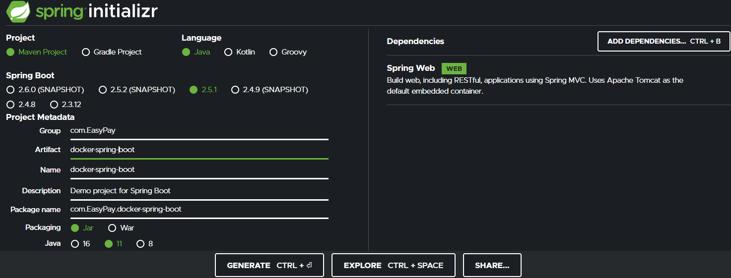

## Unzipping ‘docker-spring-boot.zip’ file Generated by Spring IO

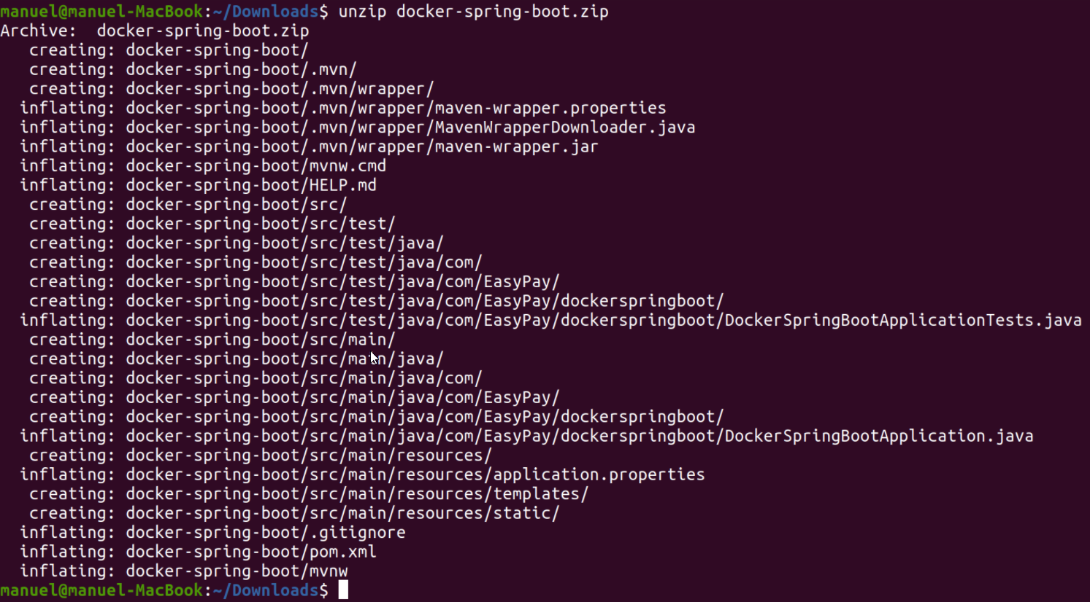

## Checking that the ‘docker-spring-boot.zip’ was successfully extracted and copying the contents to the home directory as a folder called ‘docker-spring-boot’

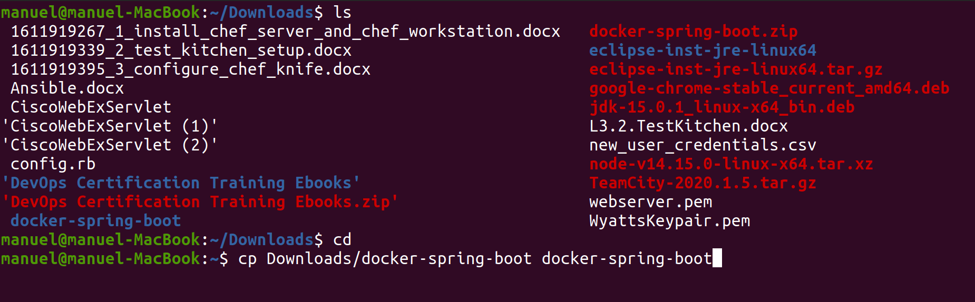

## Going to Project’s src/main/java/com/EasyPay/dockerspringboot and create a new folder called ‘resource’



## Creating HelloResource.java file



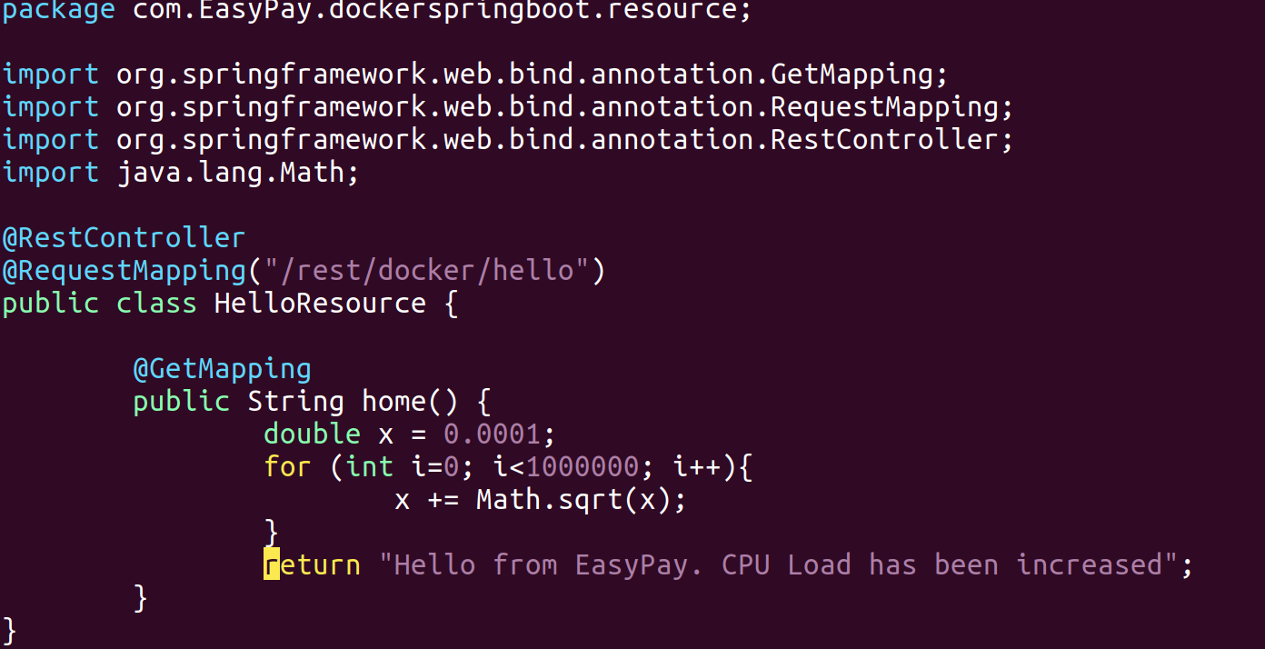

## Modifying the pom.xml file within the root directory of the project to assign a filename to the .jar file when we run Maven Install

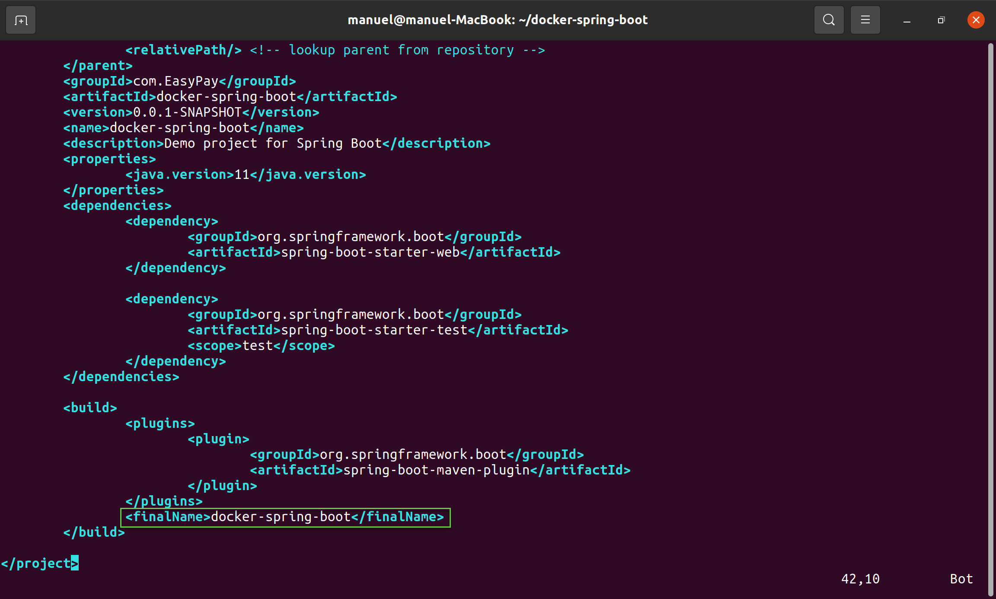

## Running mvn install in project’s root folder and showing a successful build

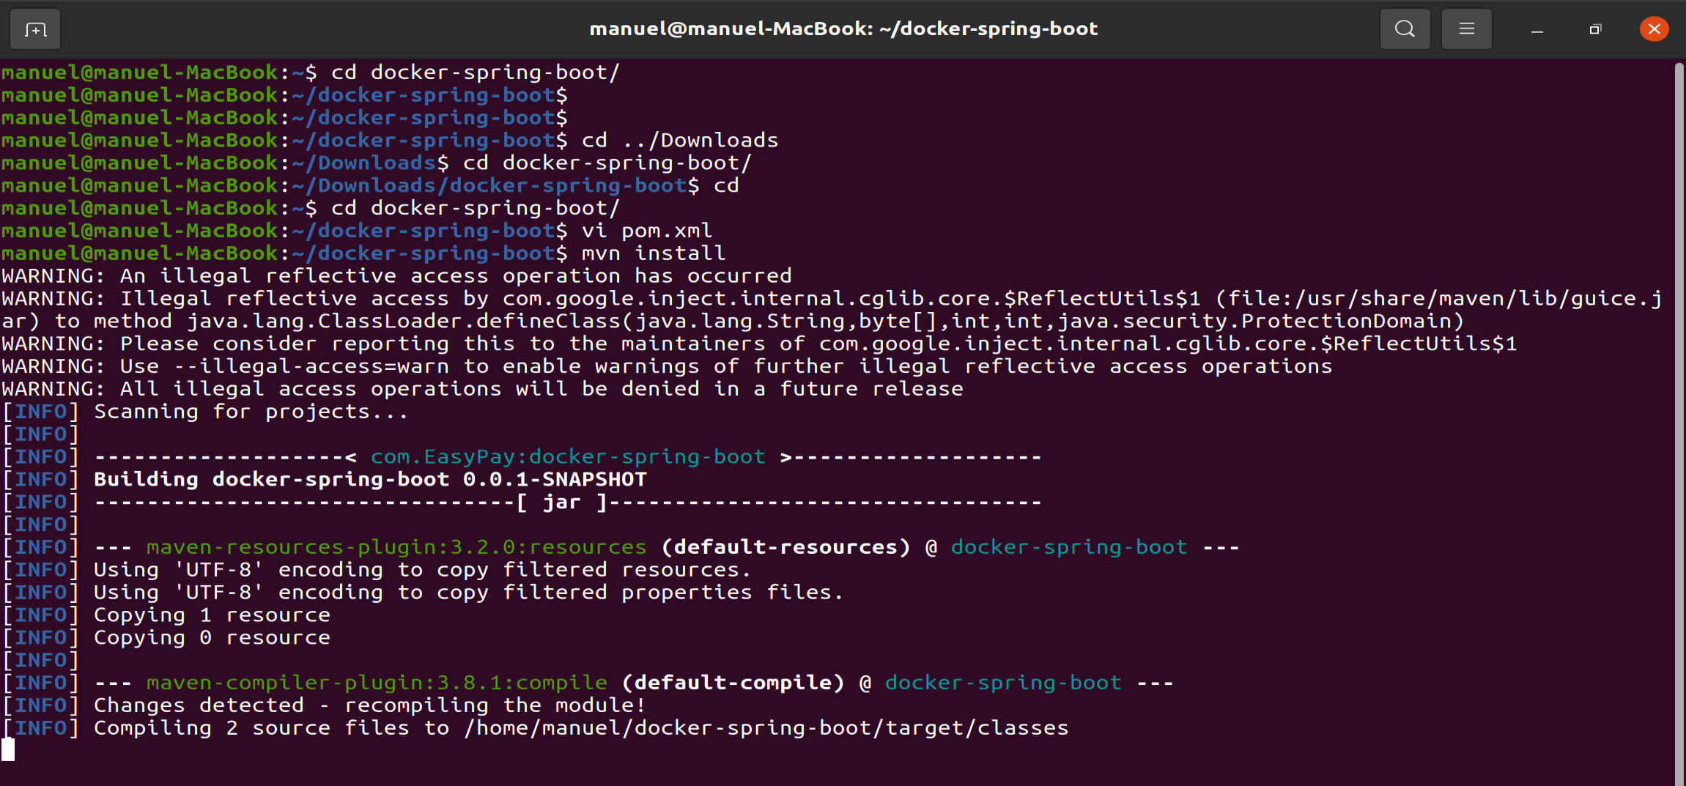

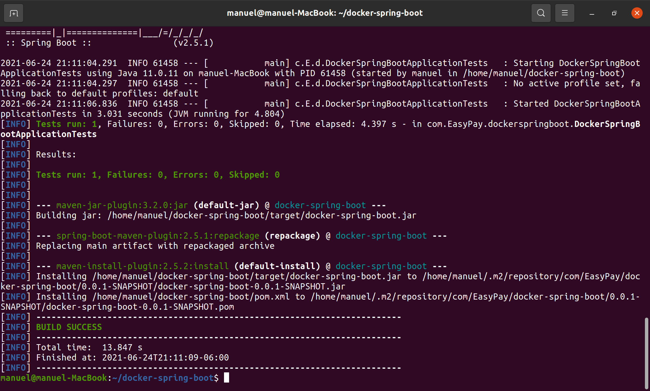

## Checking new ‘target’ folder created after running mvn install and making sure there is a **docker-spring-boot.jar** file within the directory



# Dockerizing EasyPay Application

## Creating Dockerfile in project’s root directory



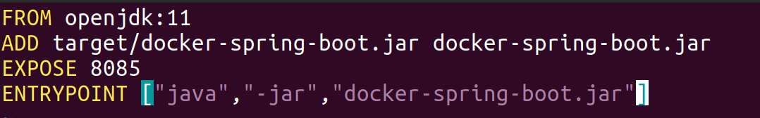

## Creating DockerHub repository for Project

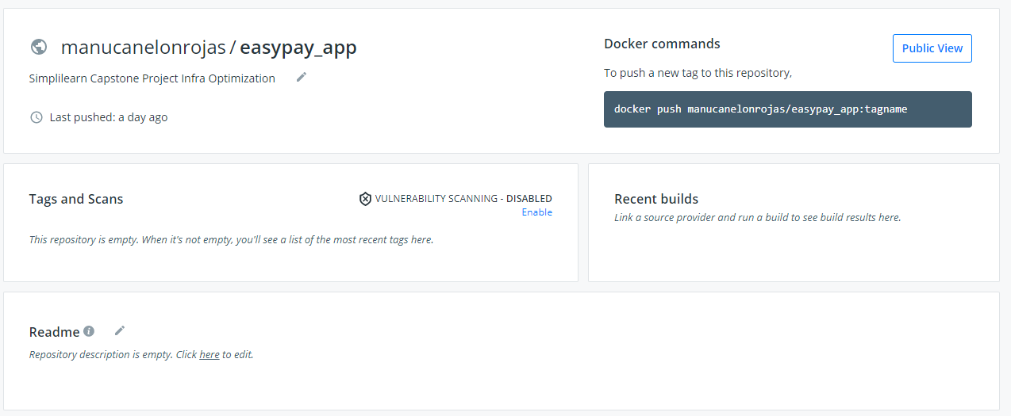

## Building Image tagging the image as per the DockerHub repository

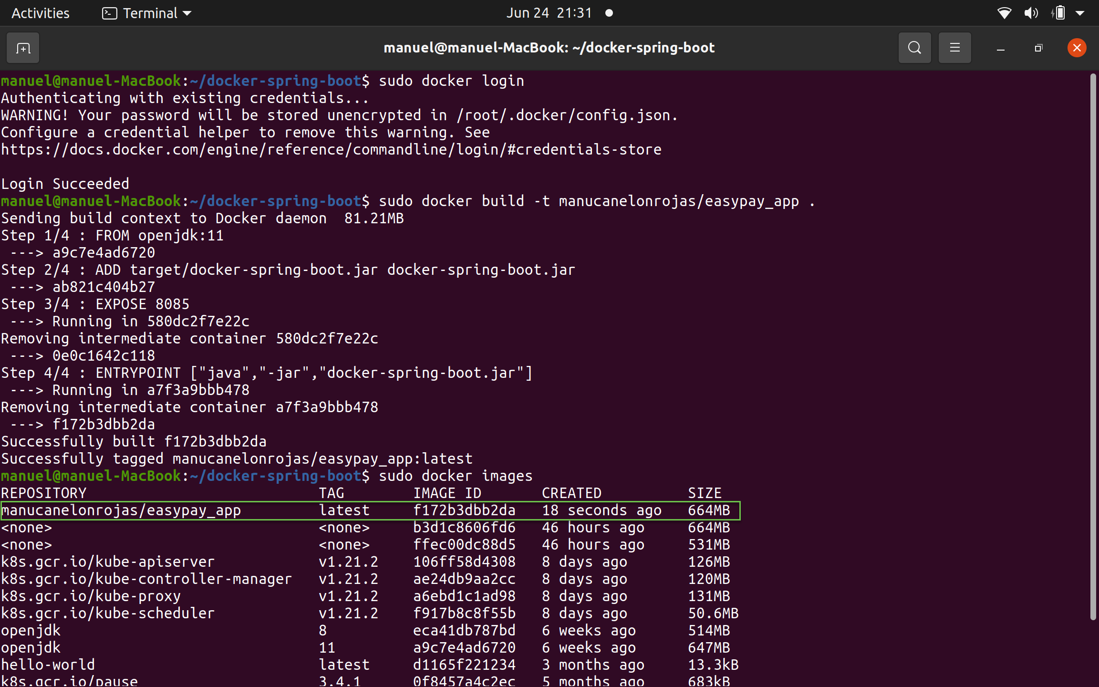

## Testing Docker Image

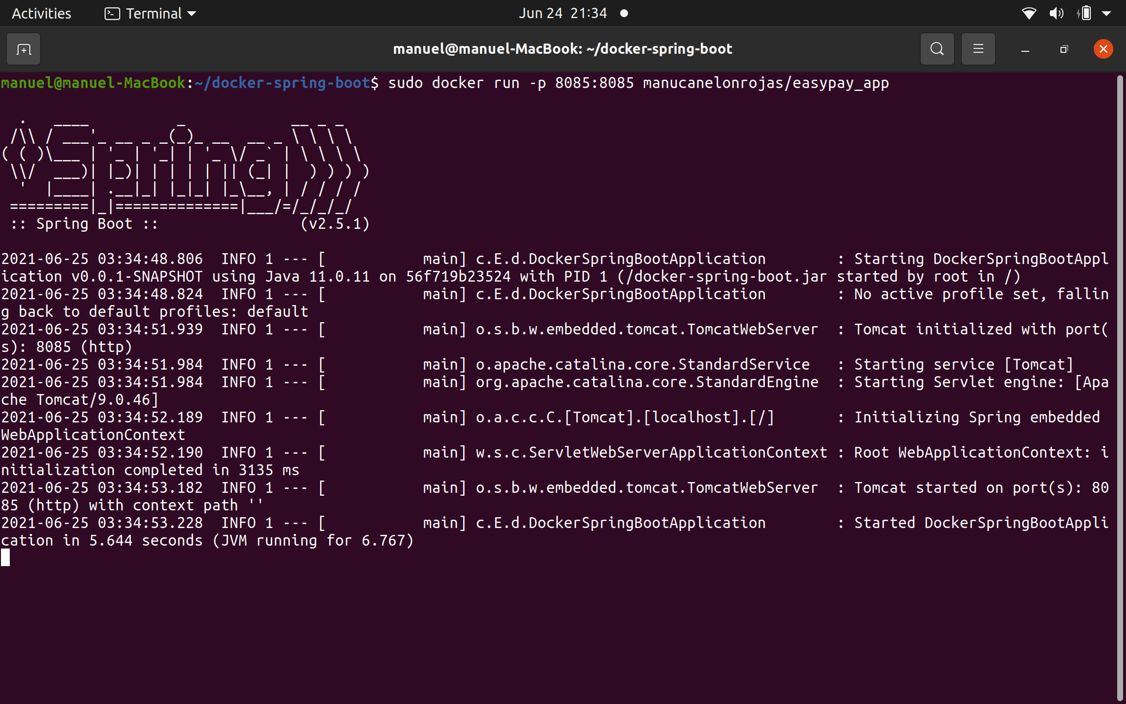

## Confirming that I can access **localhost:8085/rest/docker/hello** to show message from HelloResource.java

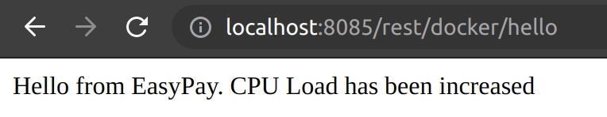

## Checking all containers, we see our container which was stopped about a minute ago



## Pushing the Docker Image to DockerHub

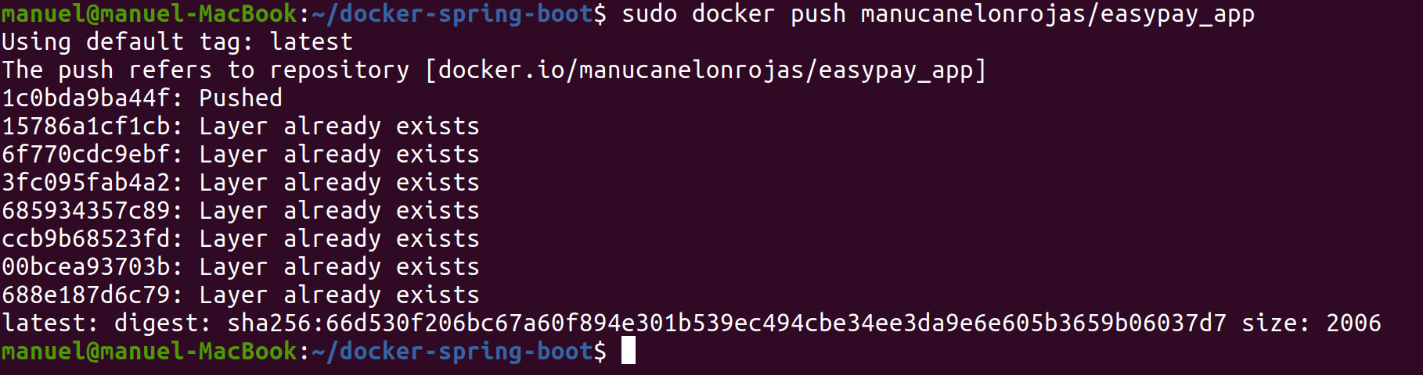

## Confirming that the Docker Image is now visible in DockerHub repository

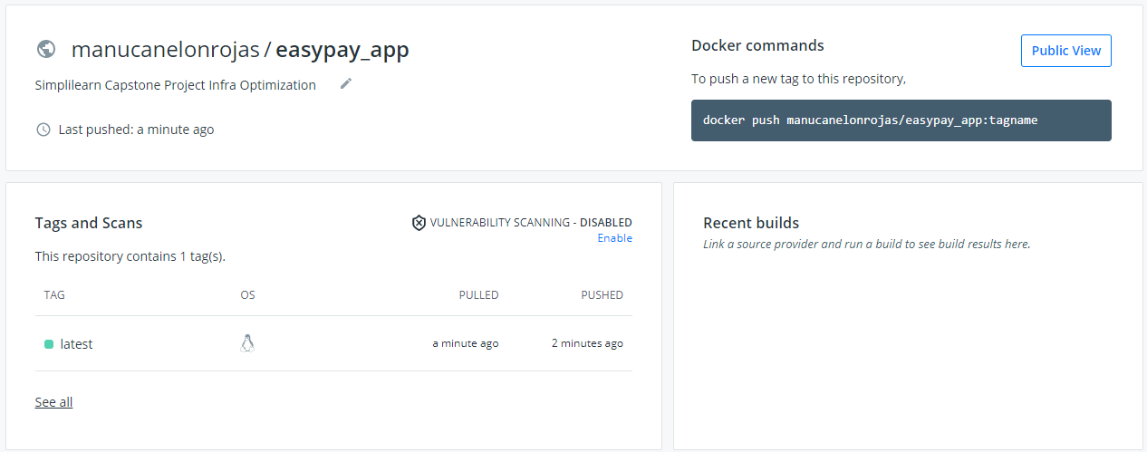

# Creating EC2 instances through Ansible

## Creating a KeyPair in AWS

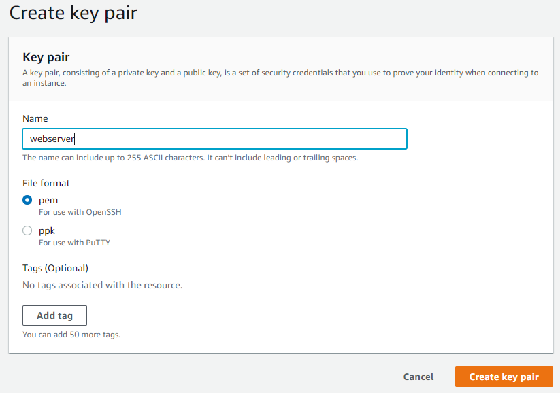

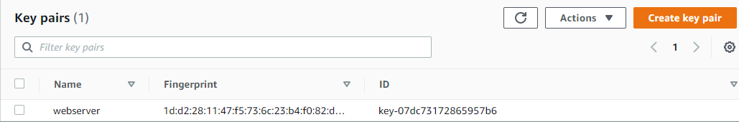

## Creating Ansible Playbook **EC2_Launcher.yml** to provision 3 EC2 instances using webserver key



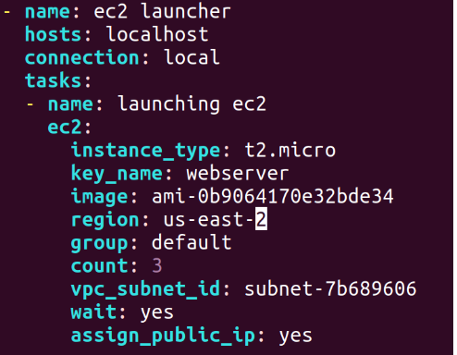

## Adding AWS Credentials to .boto file to allow Ansible to connect to AWS IAM Account

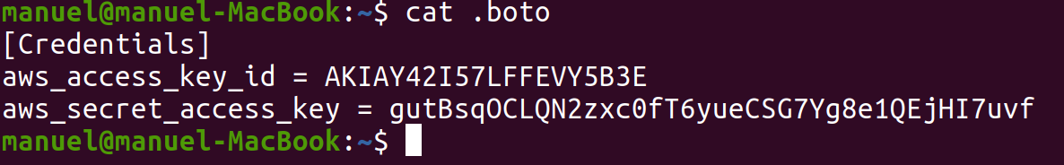

## Running Ansible Playbook **EC2_Launcher.yml**

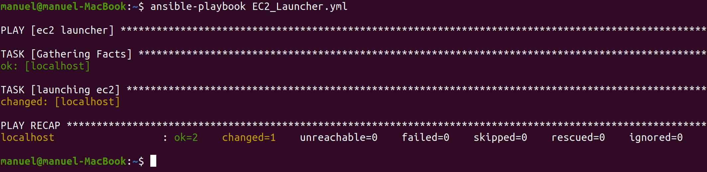

## Checking AWS to make sure that 3 EC2 instances are initialized

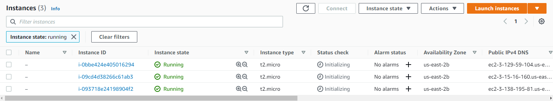

## Making sure the 3 EC2 instances are created successfully and in Running state



## Assigning Master, Node1, Node2 names to the instances

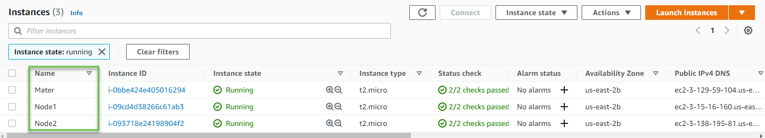

# Assigning Elastic IP to EC2 Instances

## Creating Elastic IP Addresses

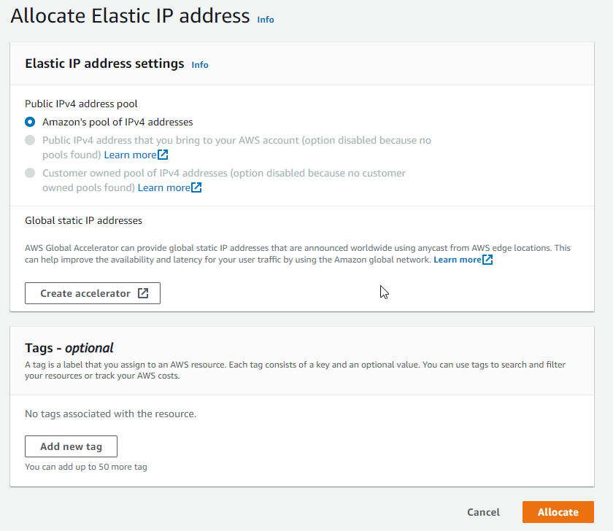

## Assigning names and Allocating Elastic IP Addresses to EC2 Instances

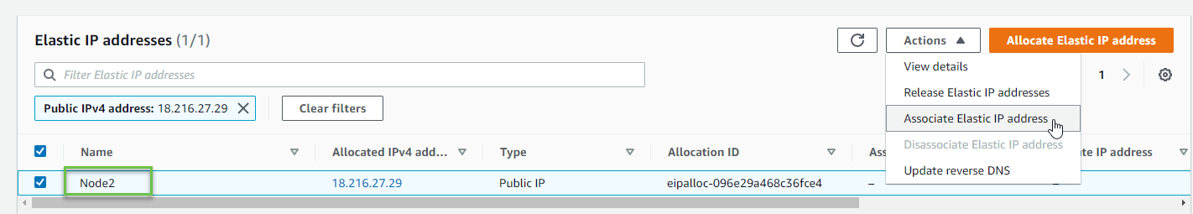

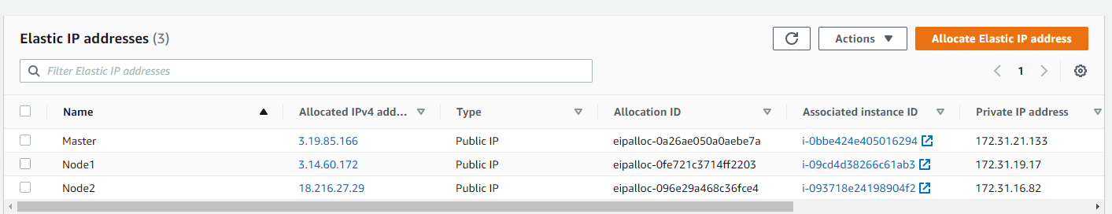

# Assigning Load Balancer to EC2 Instances

## Going to Load Balancer section, selecting **Create Load Balancer**, and choosing a BL type

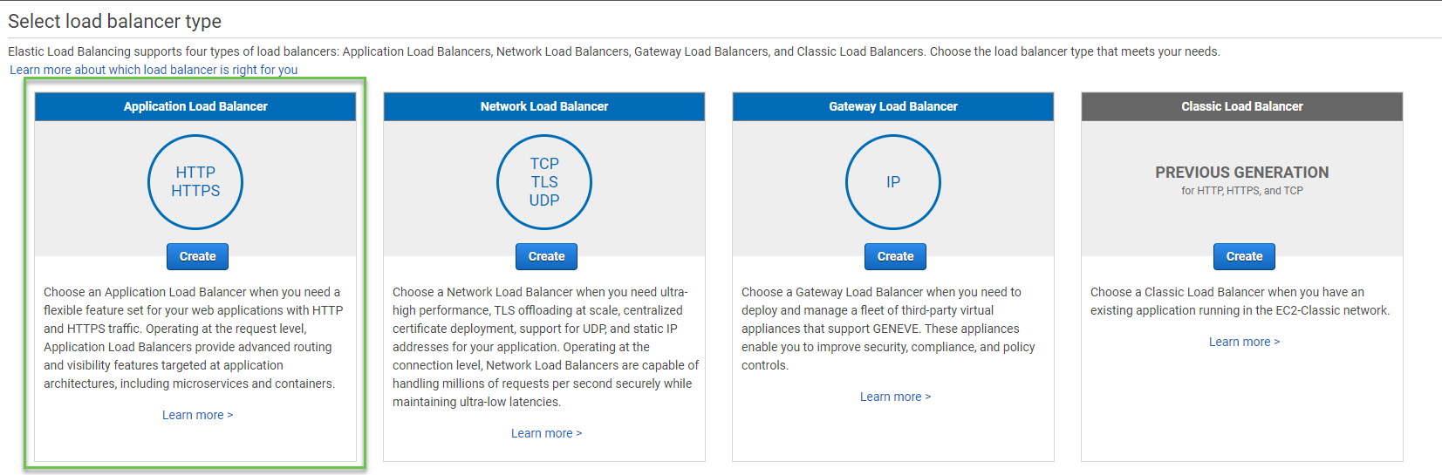

## Configuring **easypay-app-alb** Load Balancer

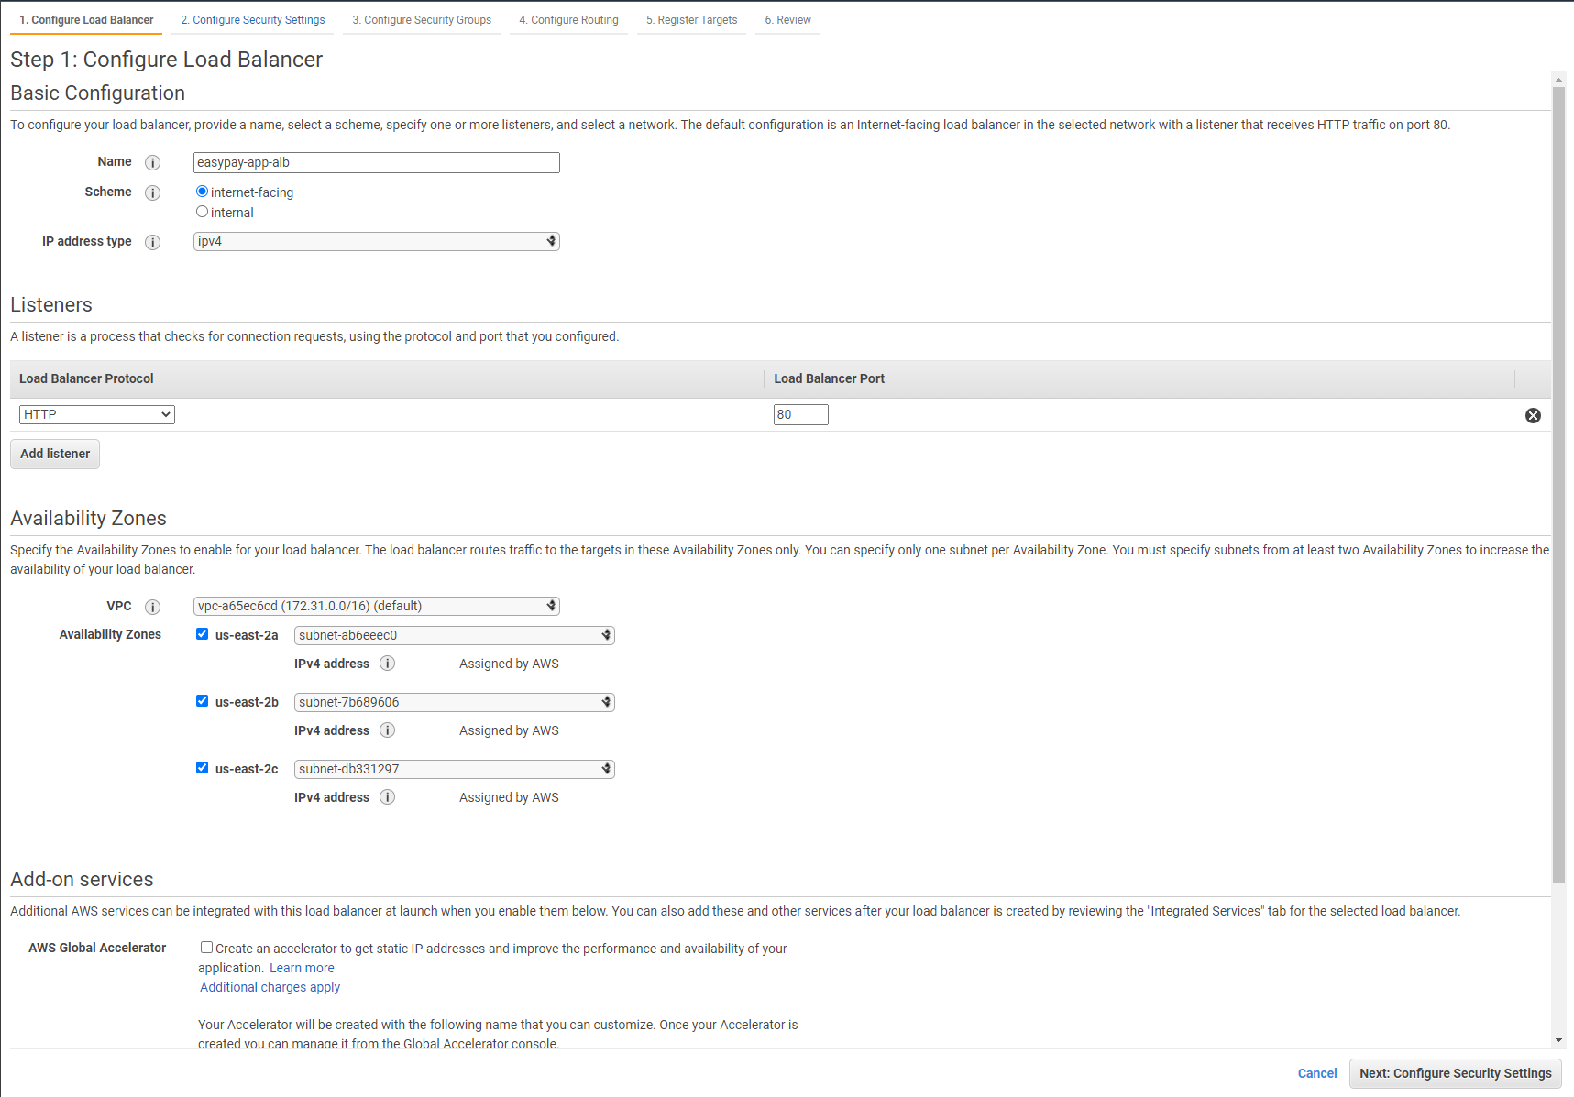

## Configuring new **easypay-app-security-group** Security Group allowing access from anywhere

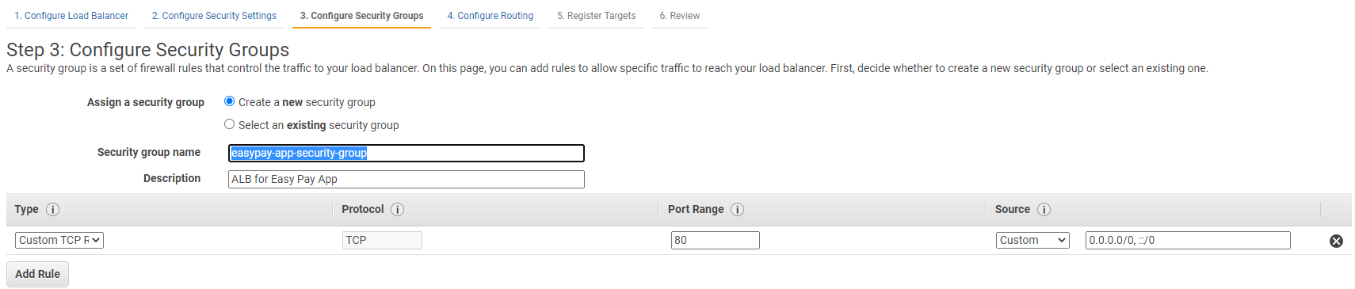

## Configuring Routes with new **easpay-target-group** Target Group

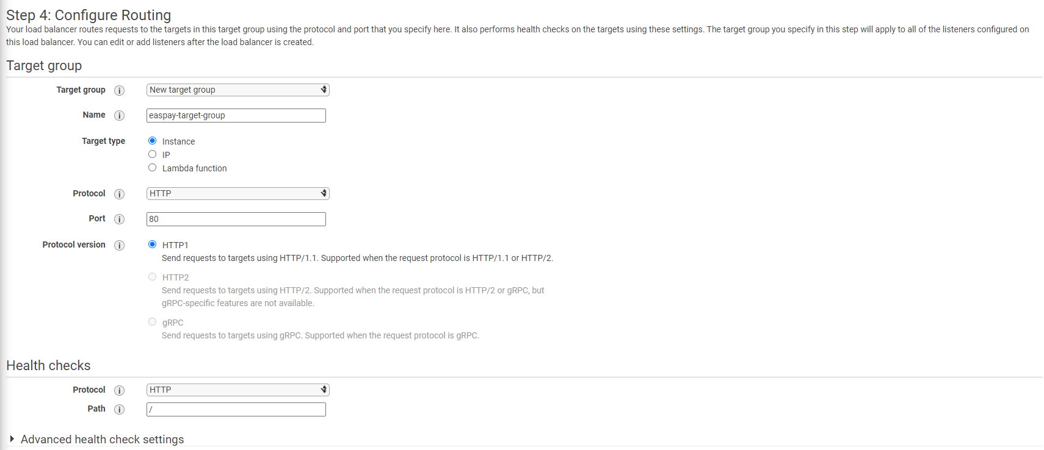

## Registering the 3 EC2 Instances as Targets

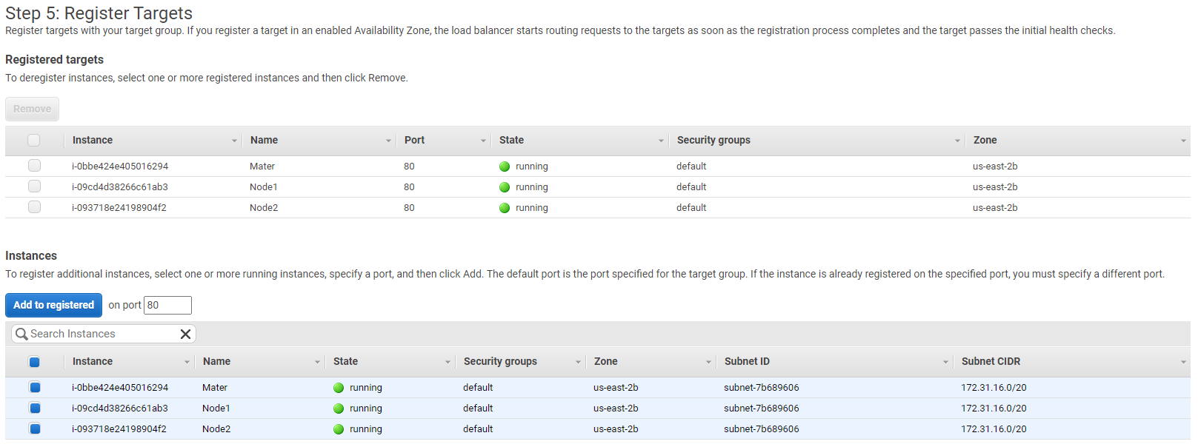

## Reviewing Load Balancer

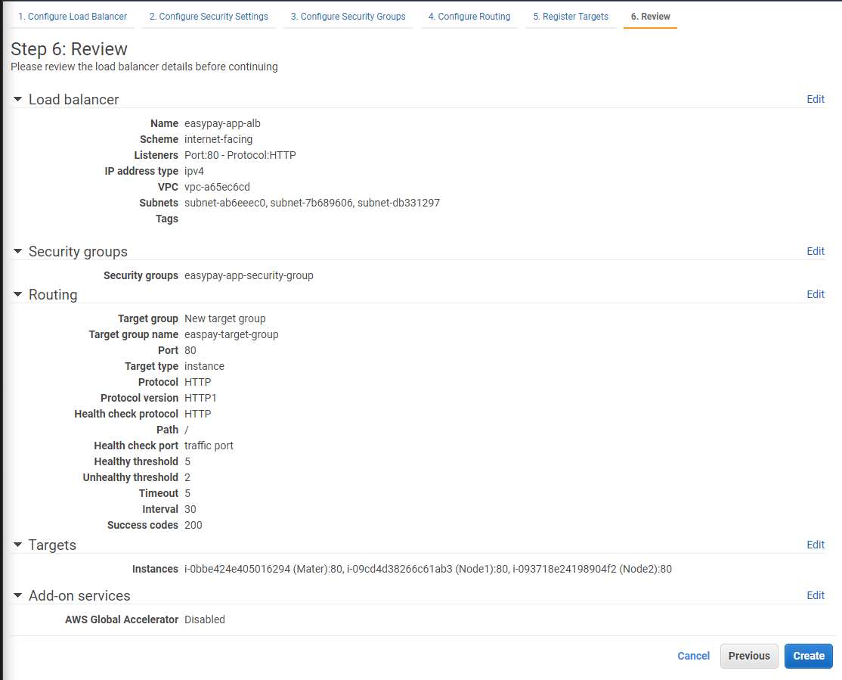

## Successful Creation Status

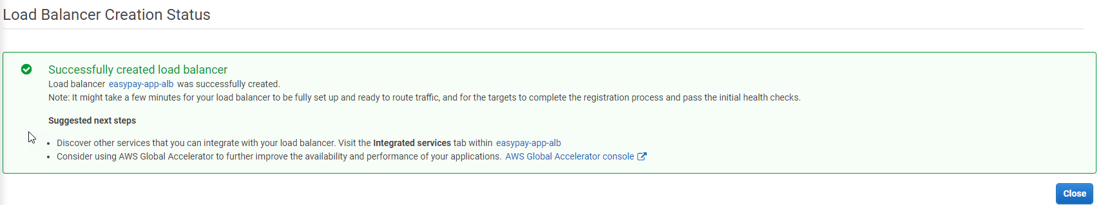

# Installing Docker and Kubernetes on EC2 Cluster/Instances

## SSH into Master EC2 Instance (Master Node) and change host name to **master.example.com**

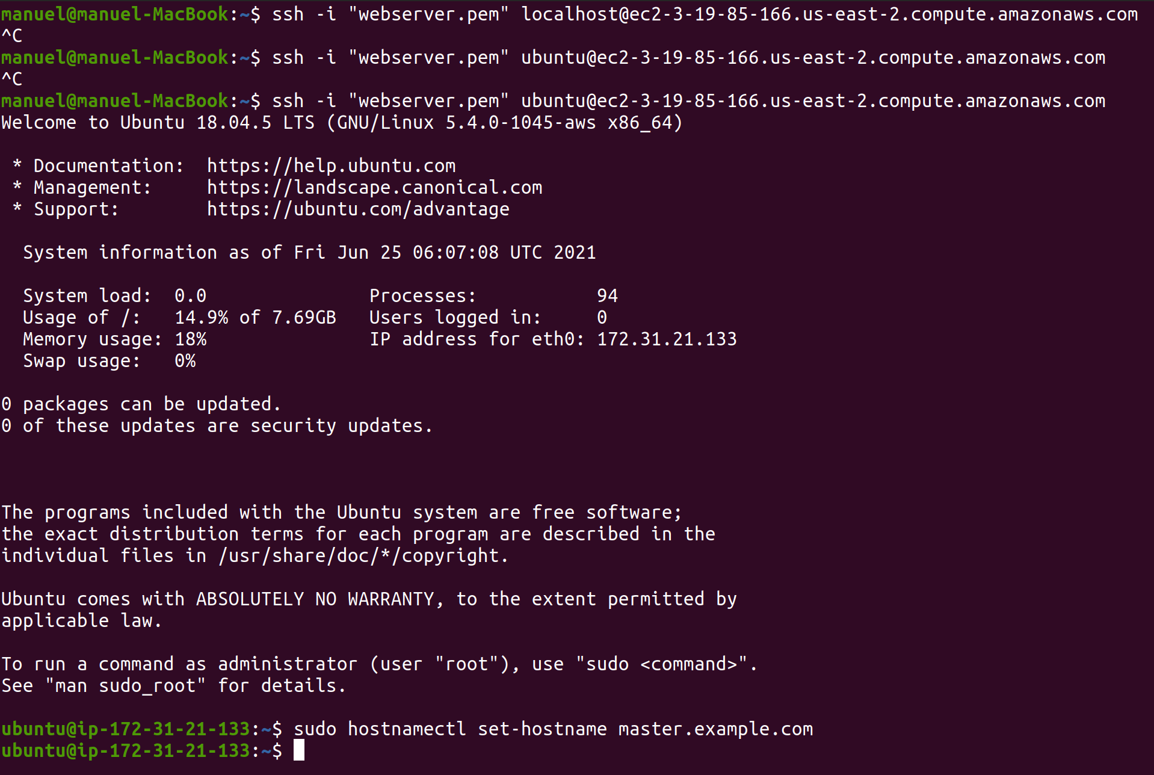

## Closing connection and reconnecting to see hostname change

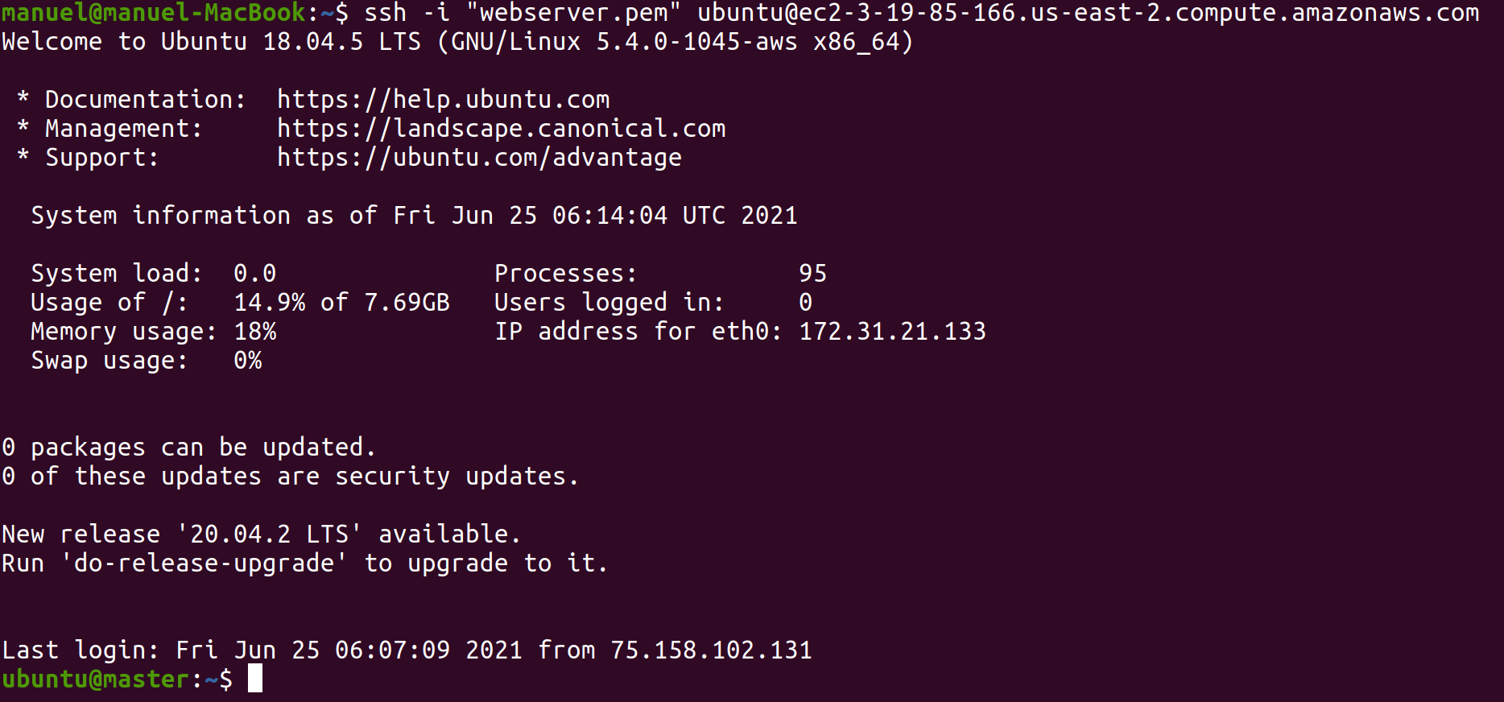

## Installing Docker following <https://docs.docker.com/engine/install/ubuntu/>

1. sudo apt-get update
2. sudo apt-get install \

apt-transport-https \

ca-certificates \

curl \

gnupg \

lsb-release

1. curl -fsSL https://download.docker.com/linux/ubuntu/gpg | sudo gpg --dearmor -o /usr/share/keyrings/docker-archive-keyring.gpg
2. echo \
3. "deb [arch=amd64 signed-by=/usr/share/keyrings/docker-archive-keyring.gpg] https://download.docker.com/linux/ubuntu \
4. $(lsb_release -cs) stable" | sudo tee /etc/apt/sources.list.d/docker.list > /dev/null
5. sudo apt-get update
6. sudo apt-get install docker-ce docker-ce-cli containerd.io

## Verifying that Docker Engine is installed correctly

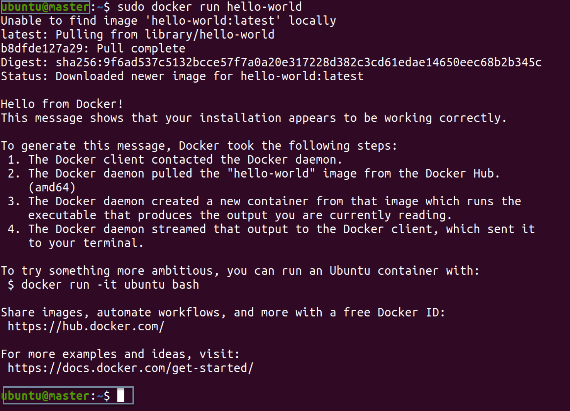

## Repeating Docker installation to Node1 (showing final confirmation only)

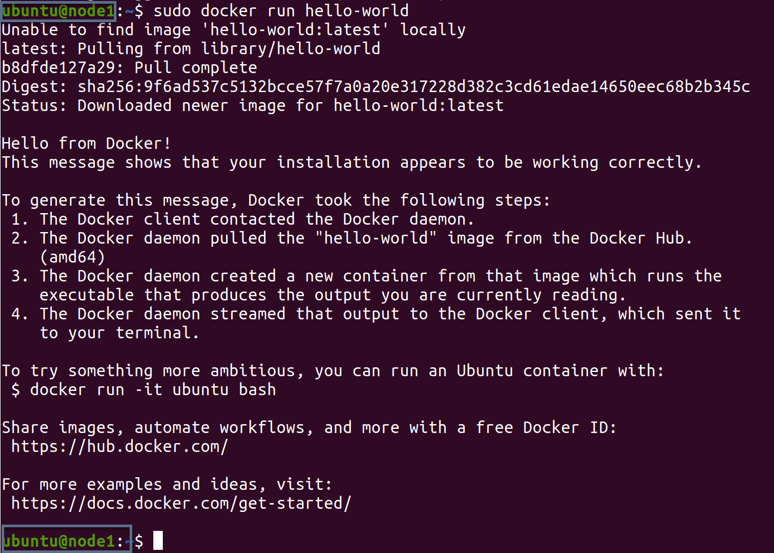

## Repeating Docker installation to Node2 (showing final confirmation only)

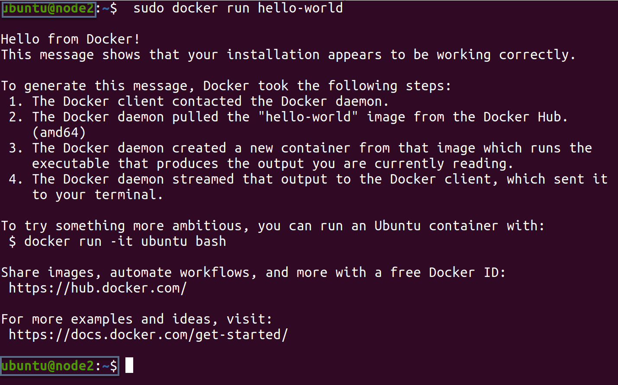

## SSH Into Master EC2 Instance (Master Node) and Install Kubernetes following the commands from <https://kubernetes.io/docs/setup/production-environment/tools/kubeadm/install-kubeadm/>

1. sudo apt-get update
2. sudo apt-get install -y apt-transport-https ca-certificates curl
3. sudo curl -fsSLo /usr/share/keyrings/kubernetes-archive-keyring.gpg <https://packages.cloud.google.com/apt/doc/apt-key.gpg>
4. echo "deb [signed-by=/usr/share/keyrings/kubernetes-archive-keyring.gpg] https://apt.kubernetes.io/ kubernetes-xenial main" | sudo tee /etc/apt/sources.list.d/kubernetes.list
5. sudo apt-get update
6. sudo apt-get install -y kubelet kubeadm kubectl
7. sudo apt-mark hold kubelet kubeadm kubectl

## Verifying that kubeadm, kubelet, kubectl are installed correctly and all with the same version on Master

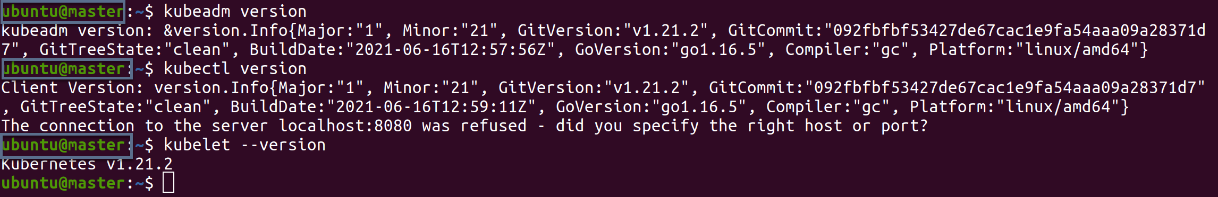

## Repeating Kubernetes installation on Node1 and verifying correct installation

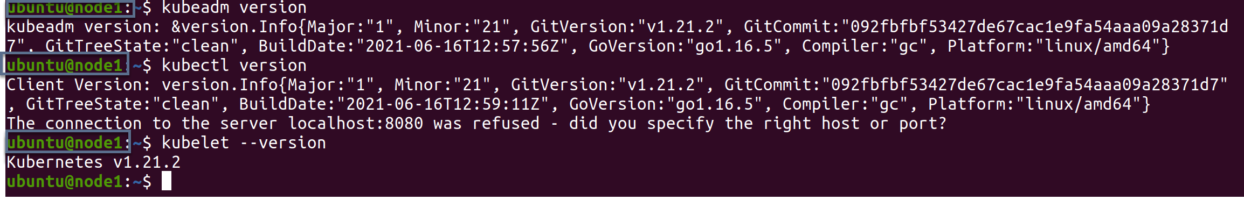

## Repeating Kubernetes installation on Node2 and verifying correct installation

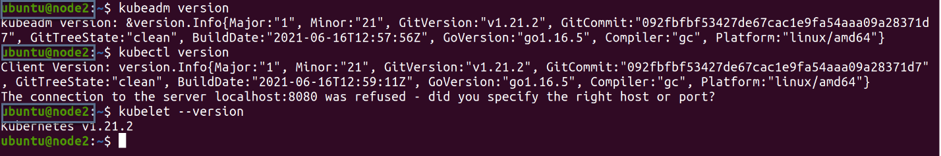

# Initializing Kubernetes Cluster

## Running **kubeadm reset** on all Nodes

### Master

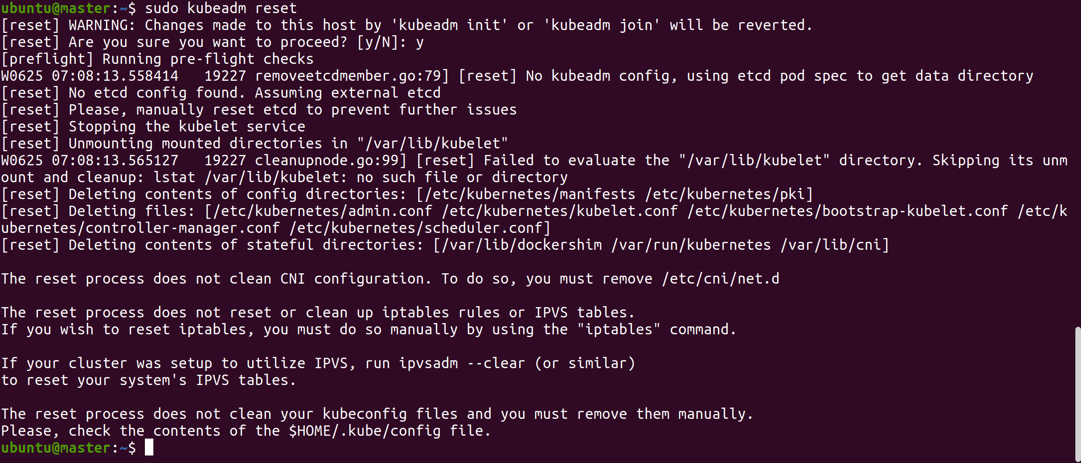

### Node1

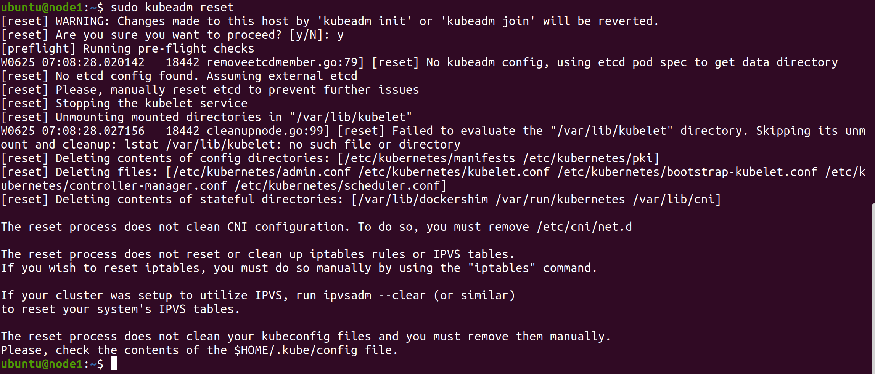

### Node2

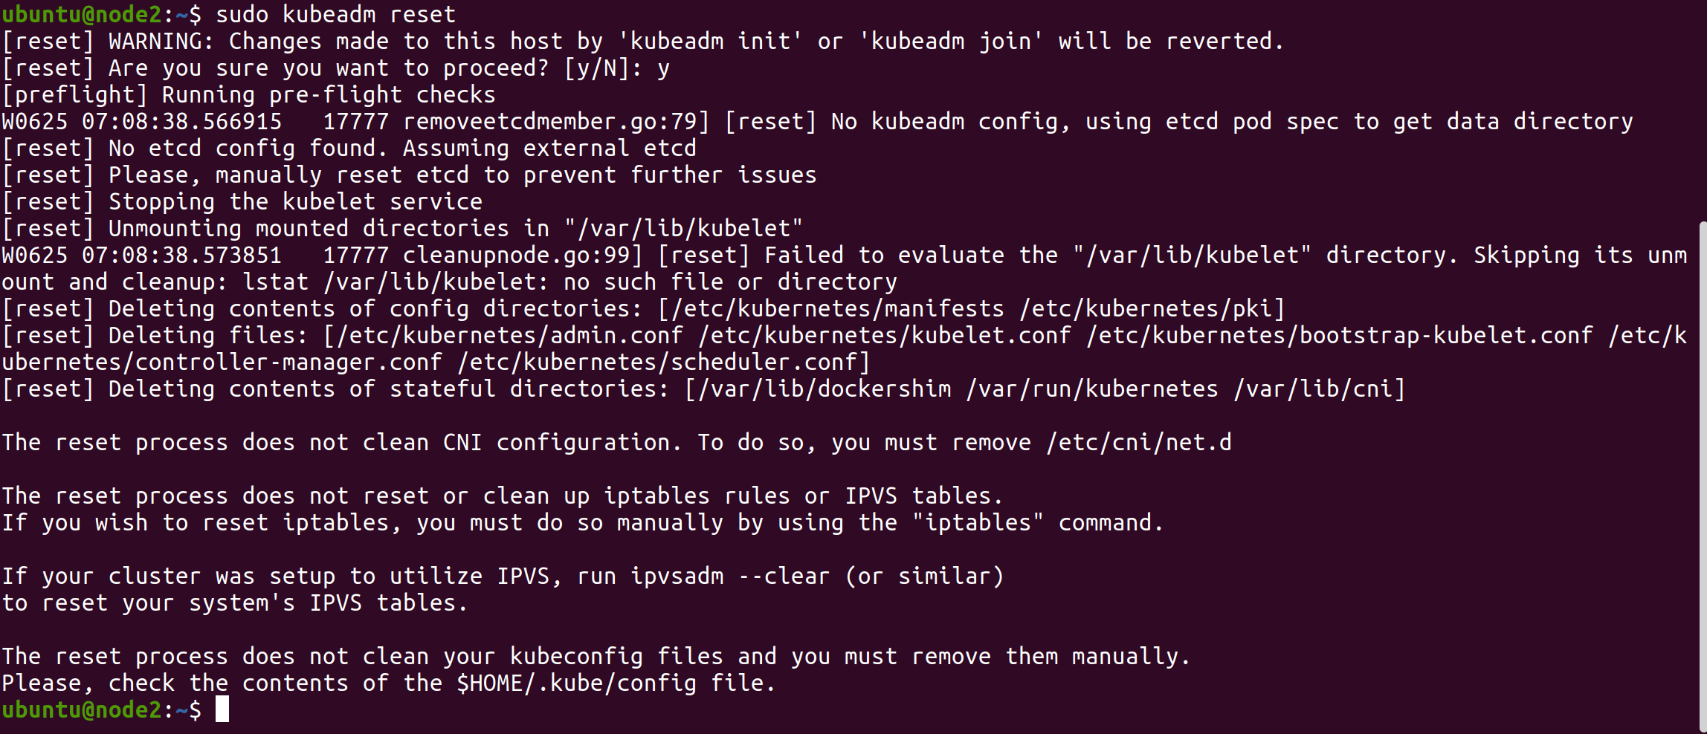

## Running **sudo kubeadm init** on Master Node

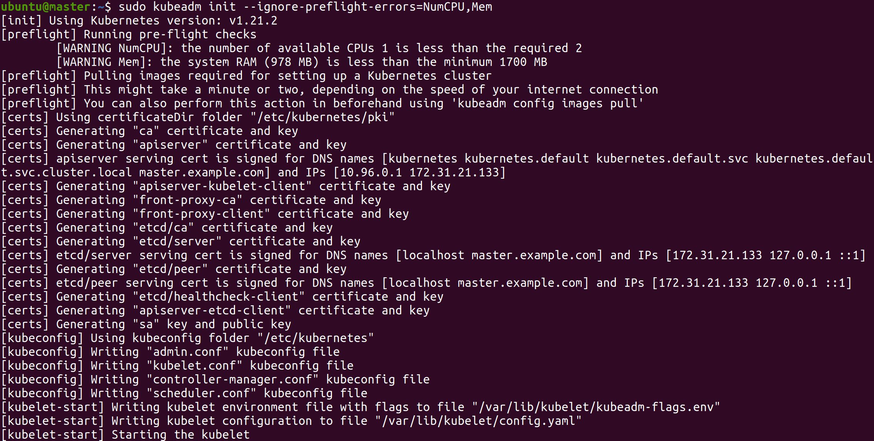

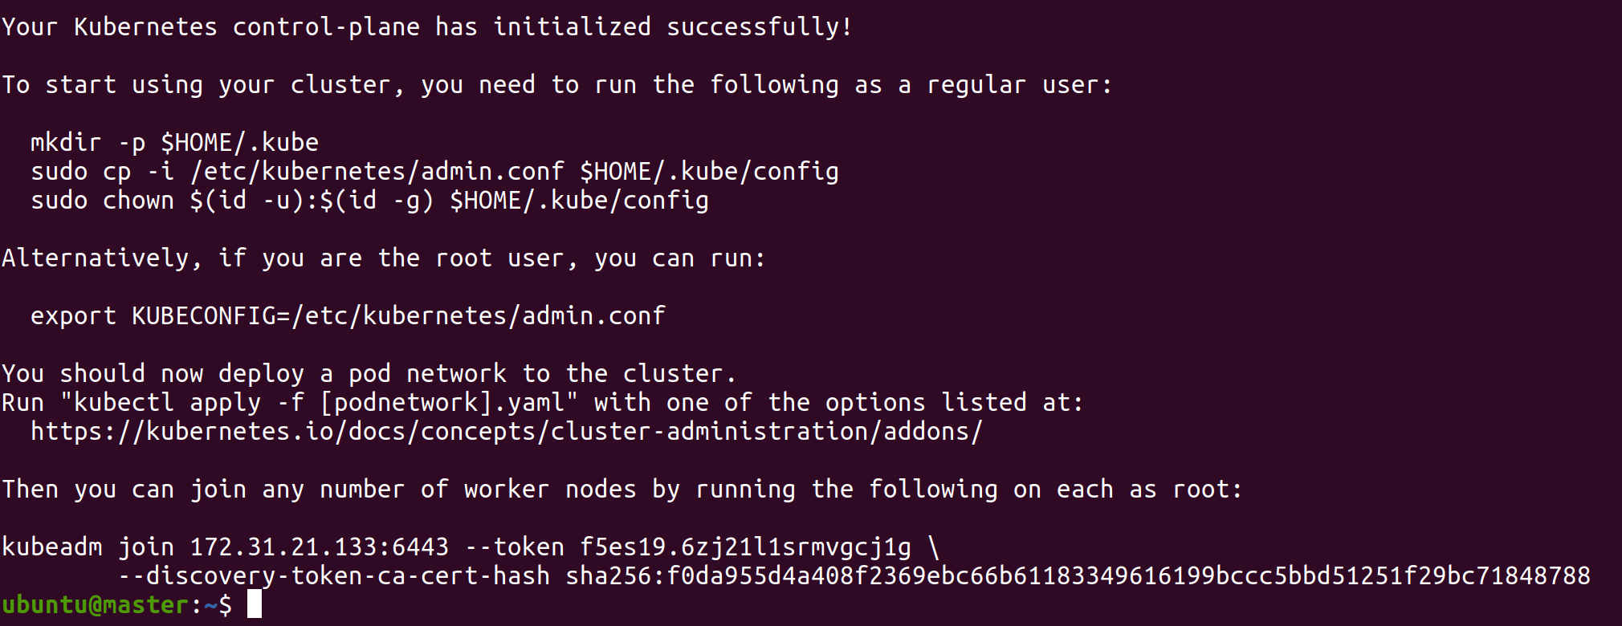

## Creating **$HOME/.kube** directory on Master to start cluster, Copying **/etc/kubernetes/admin.conf** to **$HOME/.kube/config** on Master to start cluster, Changing group ownership of **$Home/.kube/config**

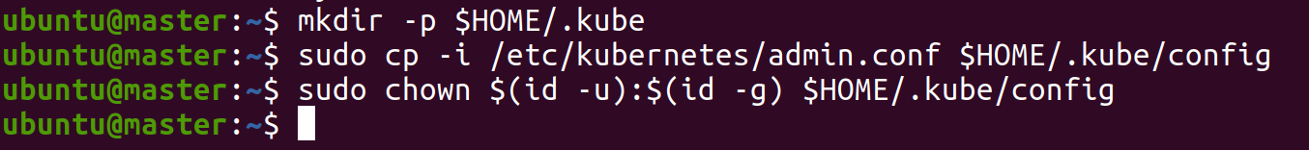

## Copying the Join command on Node 1

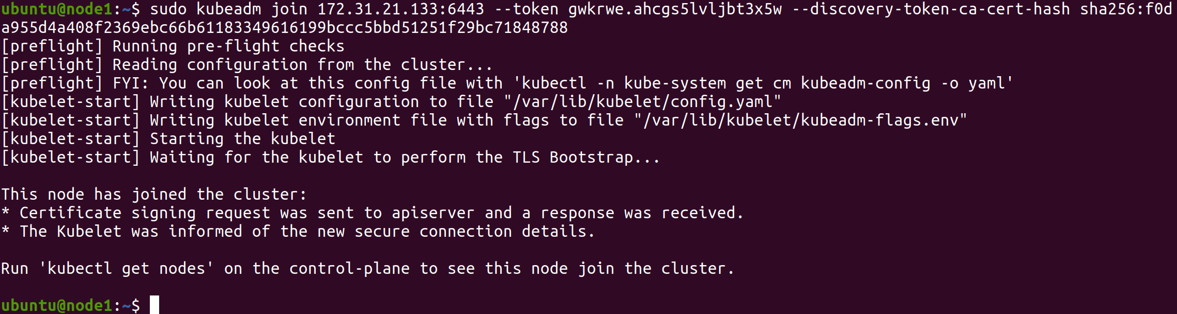

Note: The token is different to the one initially shown after the as I had to refresh the token after the **sudo kubeadm init** commandn from the Master node.

Copying the Join command on Node 2

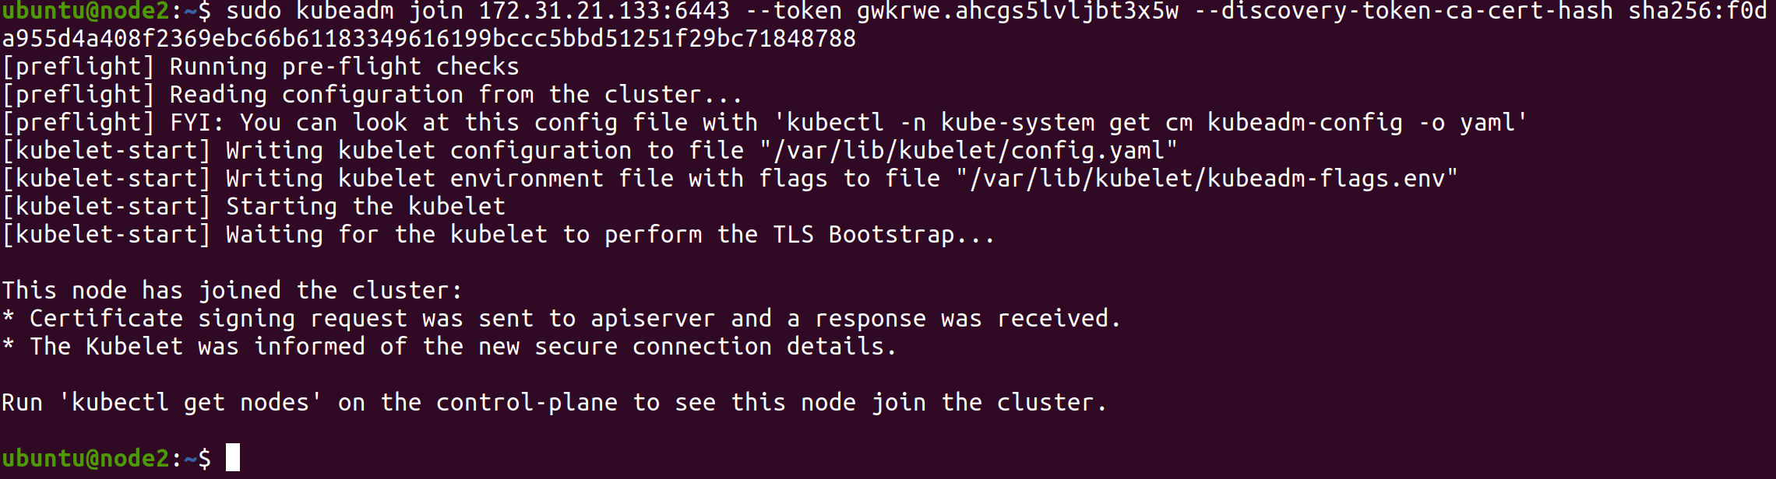

Note: The token is different to the one initially shown after the as I had to refresh the token after the **sudo kubeadm init** commandn from the Master node.

## Going to Master and running kubectl get nodes to confirm creation of Kubernetes Cluster

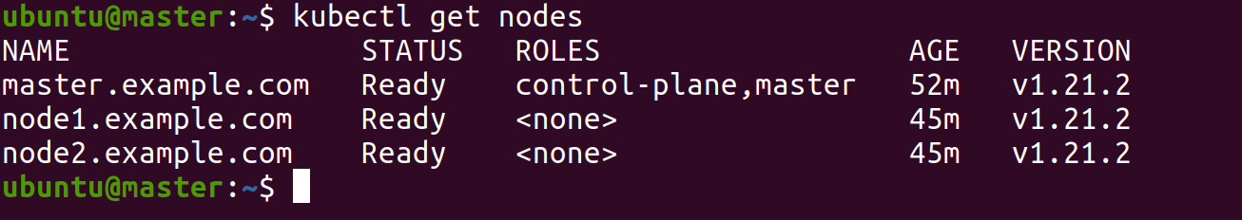

# Creating a new user with Permissions to create, list, get, update, and delete pods

## Creating **manuel** user in Master Node

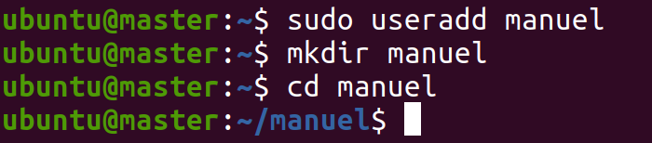

## Creating a certificate signing request for manuel.key

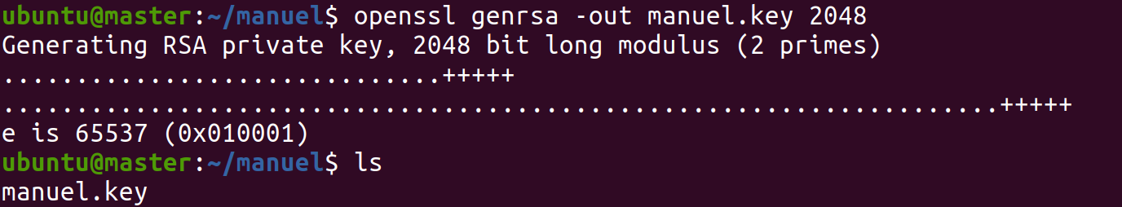

## Confirming successful creation of manuel.key

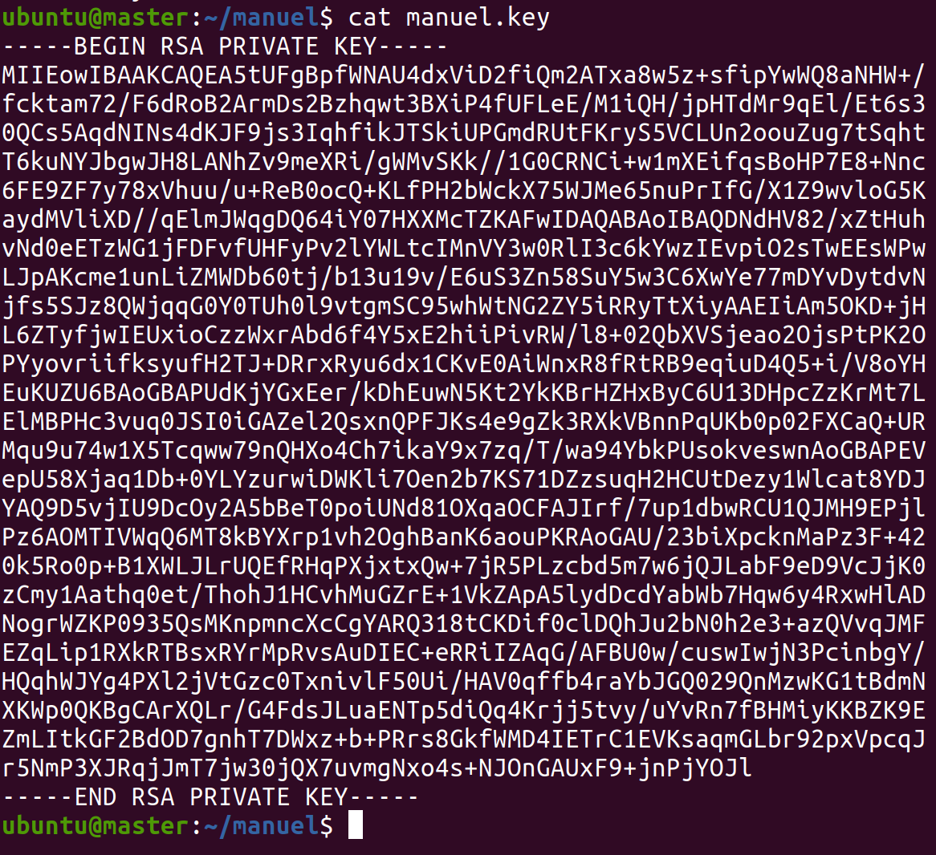

## Creating a certificate signing request for manuel.csr and confirming successful creation

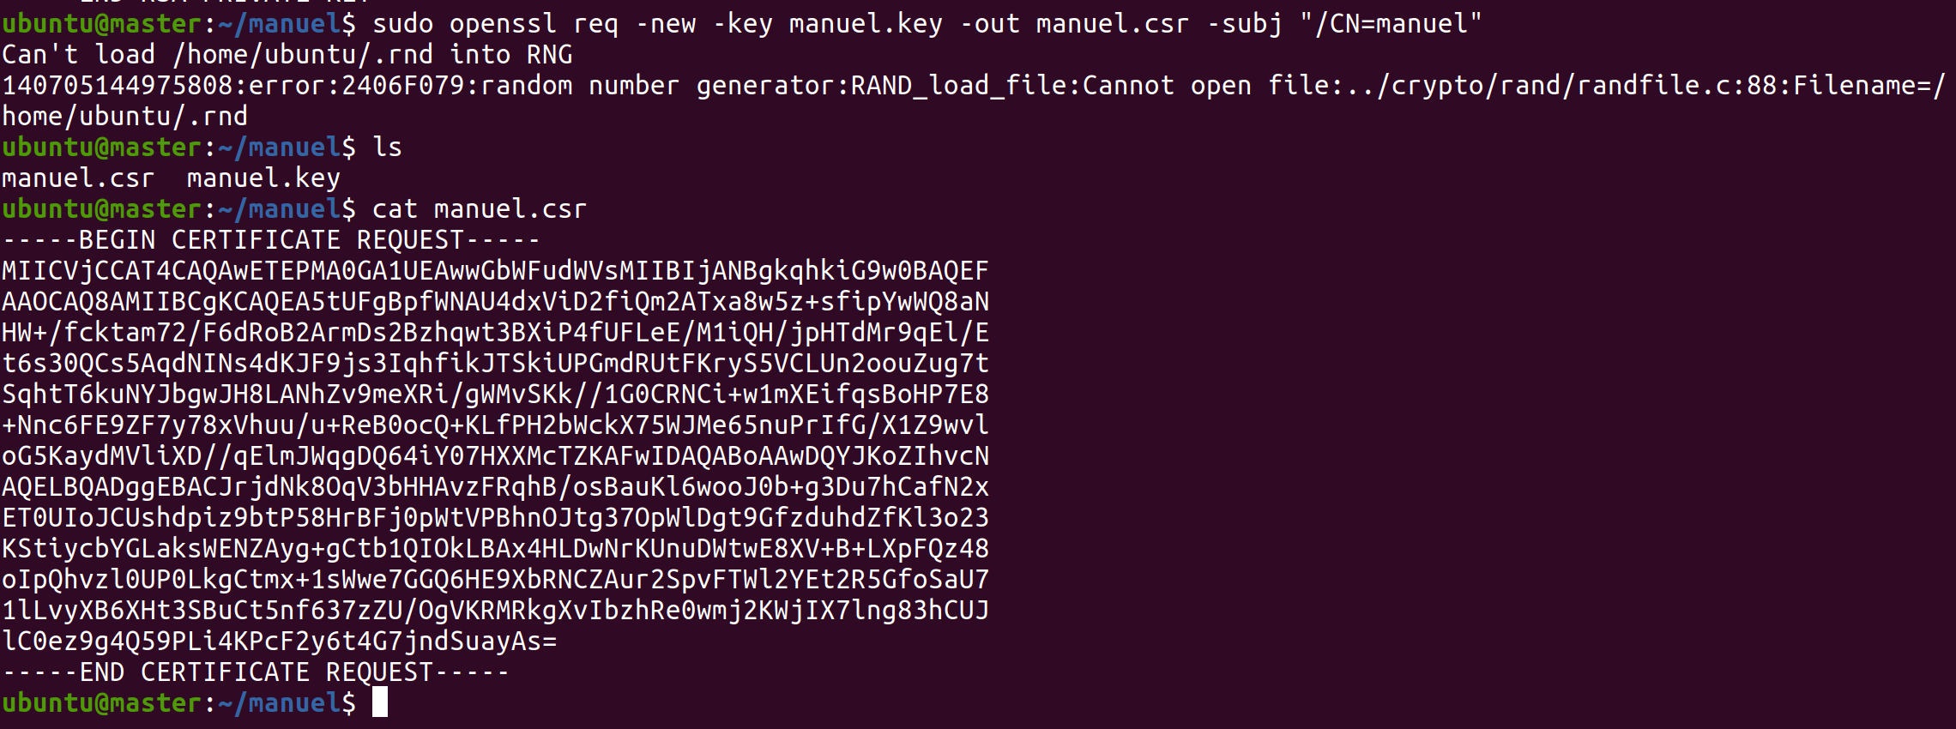

## Creating certificate signing request for manuel.crt and confirming successful creation

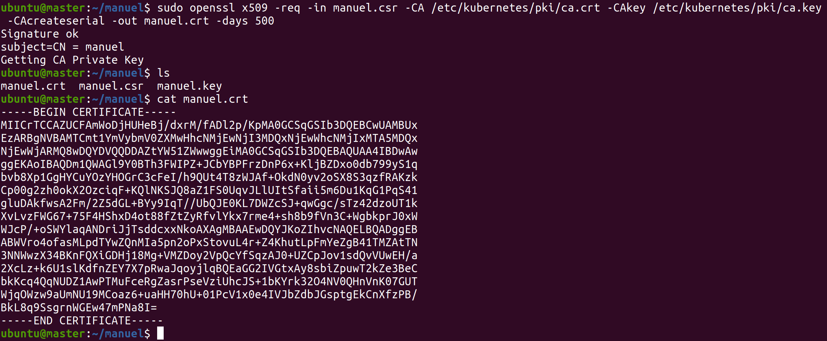

## Set Manuel’s credentials to be accepted by Kubernetes

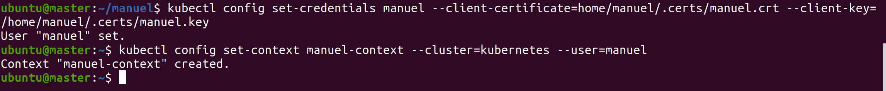

## Creating **infraproject** Namespace

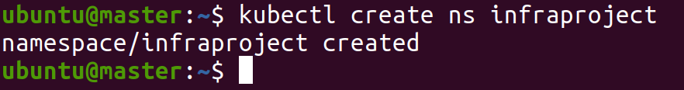

## Creating role-deployment-manager.yml

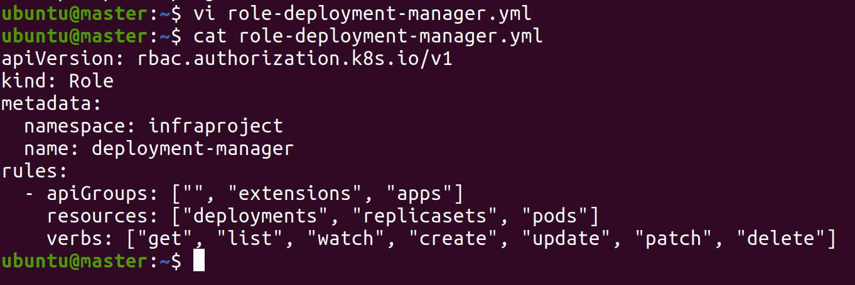

## Creating rolebinding-deployment-manager.yml

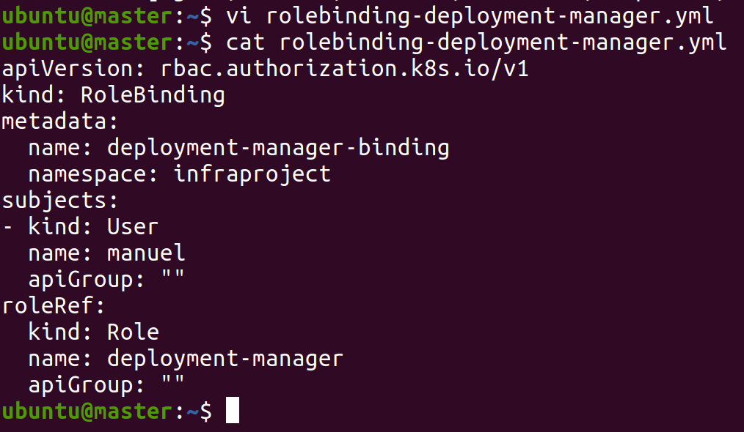

## Creating Role & RoleBinding Deployments and checking **infraproject** namespace for confirmation

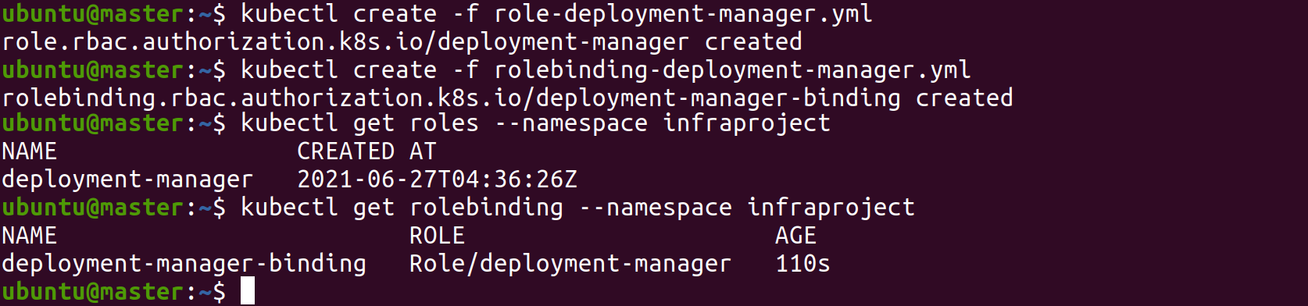

# Configuring **mysql** database as a Deployment in **infraproject** namespace

## Creating mysql.yml file

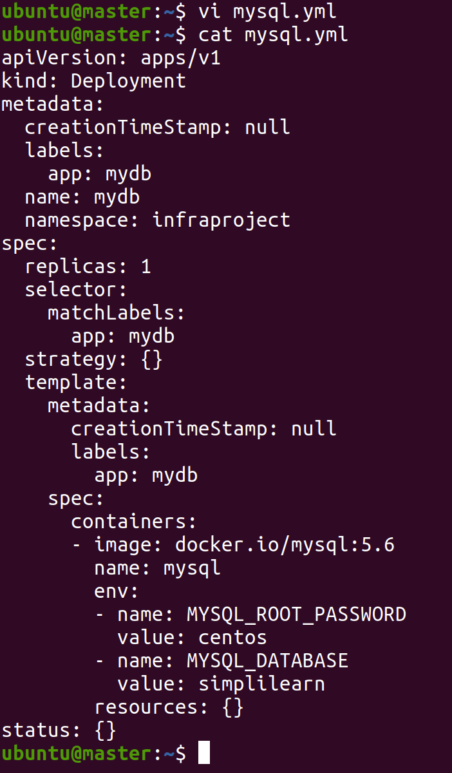

## Creating mysql Deployment

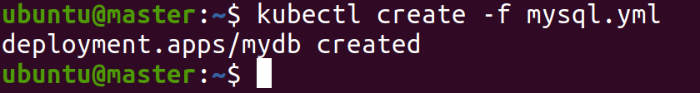

## Kubectl get pods -o wide && kubectl get deployment -o wide

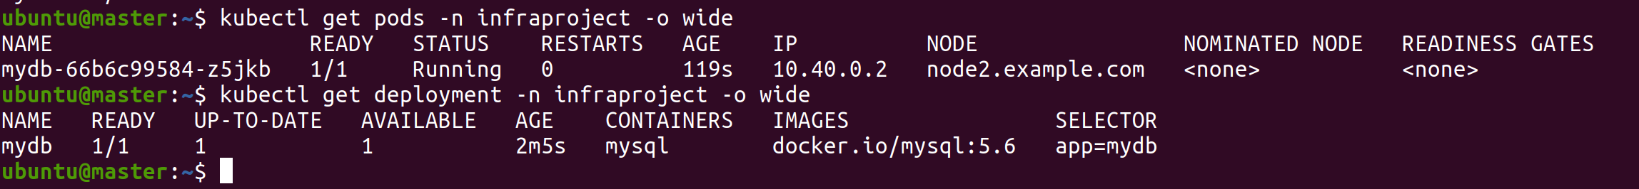

Please note that Node2 IP Address is different from the original EC2 instances. I had some issues and had to create new ones, hence the change in IP Addresses on the Nodes/EC2 Instances.

## Exec into mydb pod and show databases to demonstrate mysql deployment is running

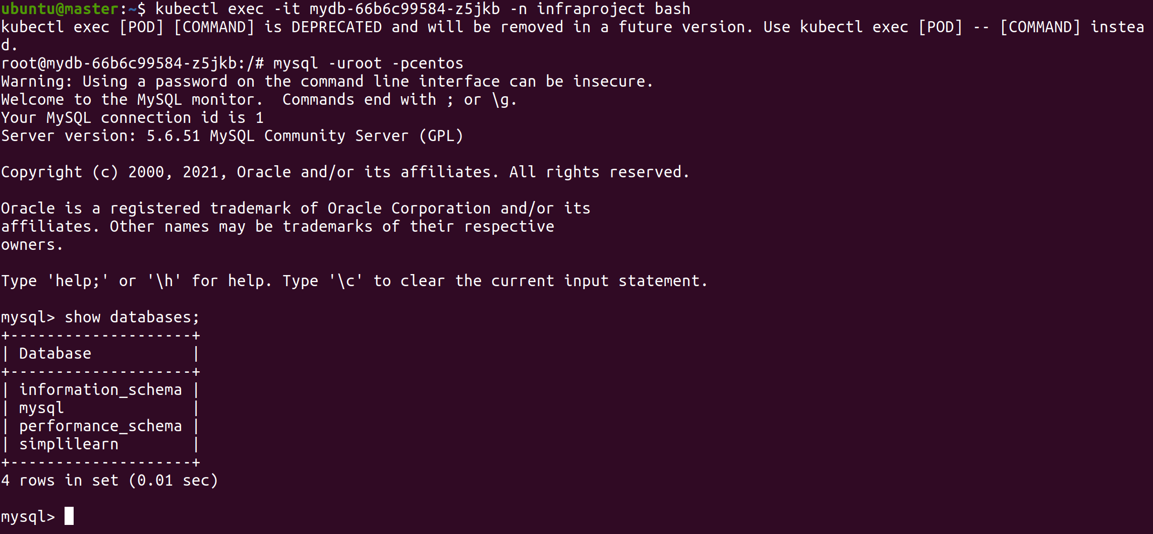

# Configuring the **EasyApp** as a Deployment, using the Docker Image built previously

## Creating easypay.yml

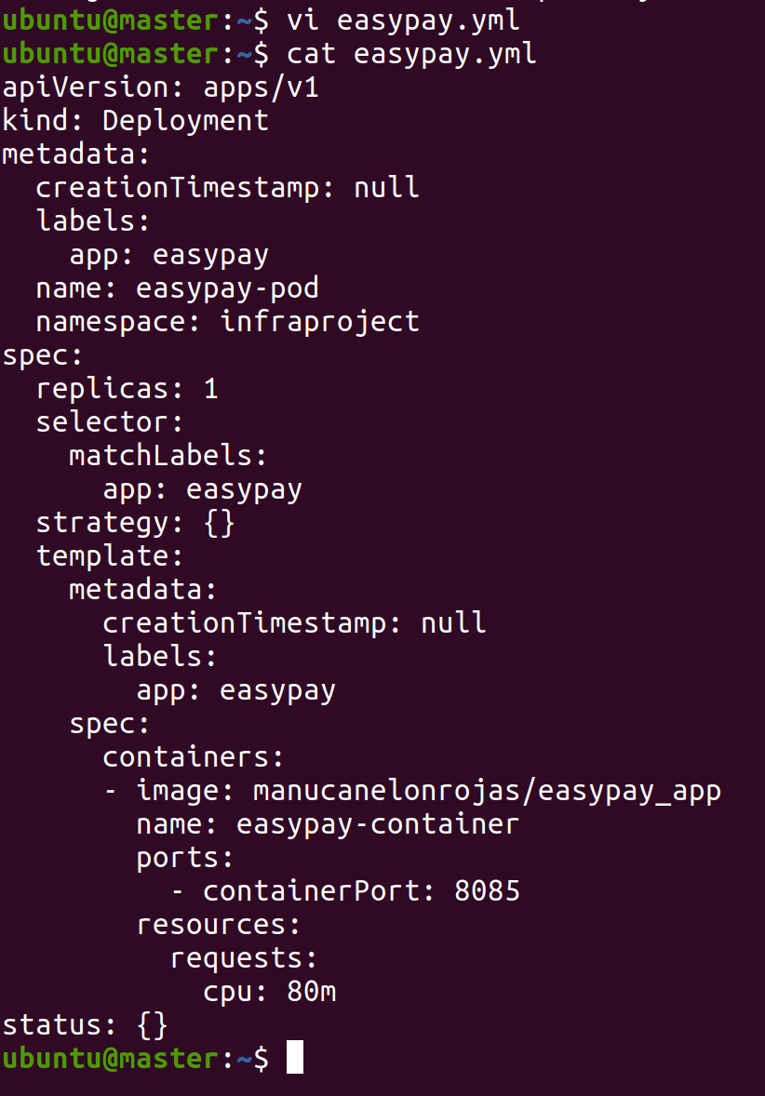

## Creating easypay Deployment

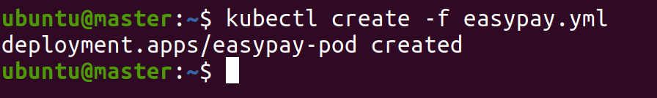

## Kubectl get pods -o wide && kubectl get deployment -o wide

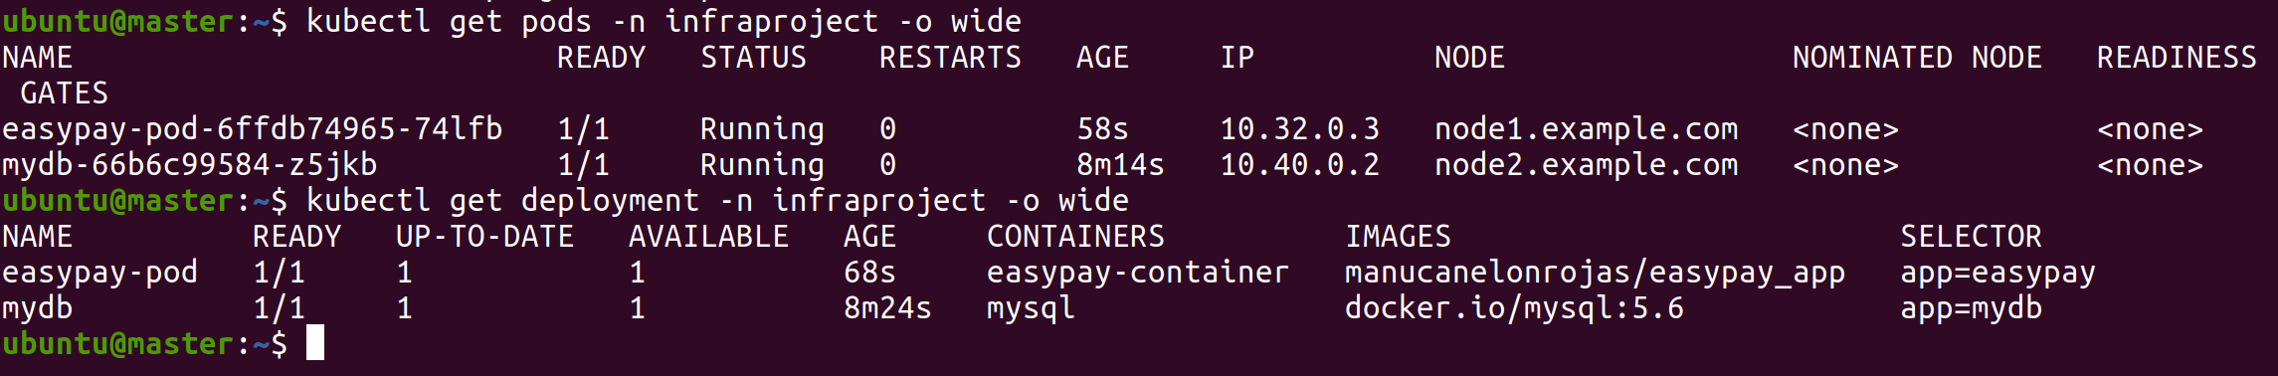

## Confirming the easypay pod is working as expected



As you can see, if we curl the IP address of the node where the pod is running, and we add curl <ip_address>**:8085/rest/docker/hello** we get the output message from the HelloResource.java file which was initially added to the Spring IO project. The port was specified in both the Docker image and easypay.yml, while the /rest/docker/hello was specified in the HelloResource.java file within the Spring IO project.

Please note the curl command shown is using a different IP Address because I had issues with my initial EC2 instances and had to trigger new ones.

# Implement the Network Policies at the DB Pod to Allow Ingress traffic from the front-end EasyApp pod

## Creating netpolicy.yml

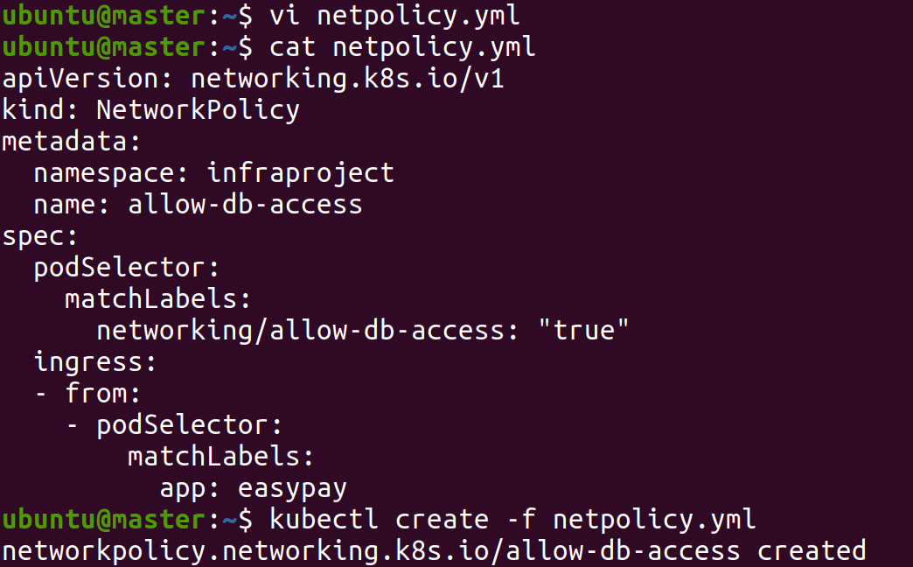

## Kubectl get networkpolicy -n infraproject

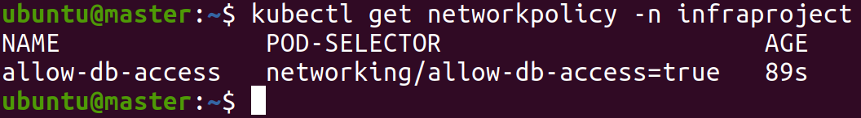

# Configuring Horizontal Pod Autoscaler when CPU Utilization exceeds 50%

## Applying Metric Server

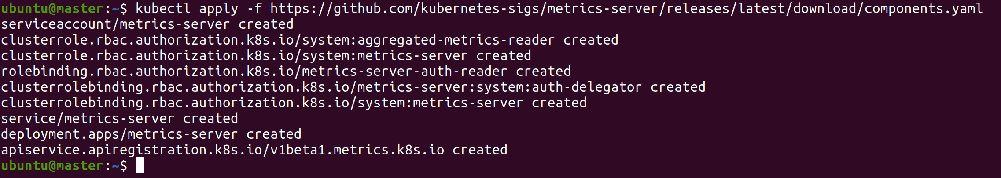

## Kubectl get pods -n kube-system

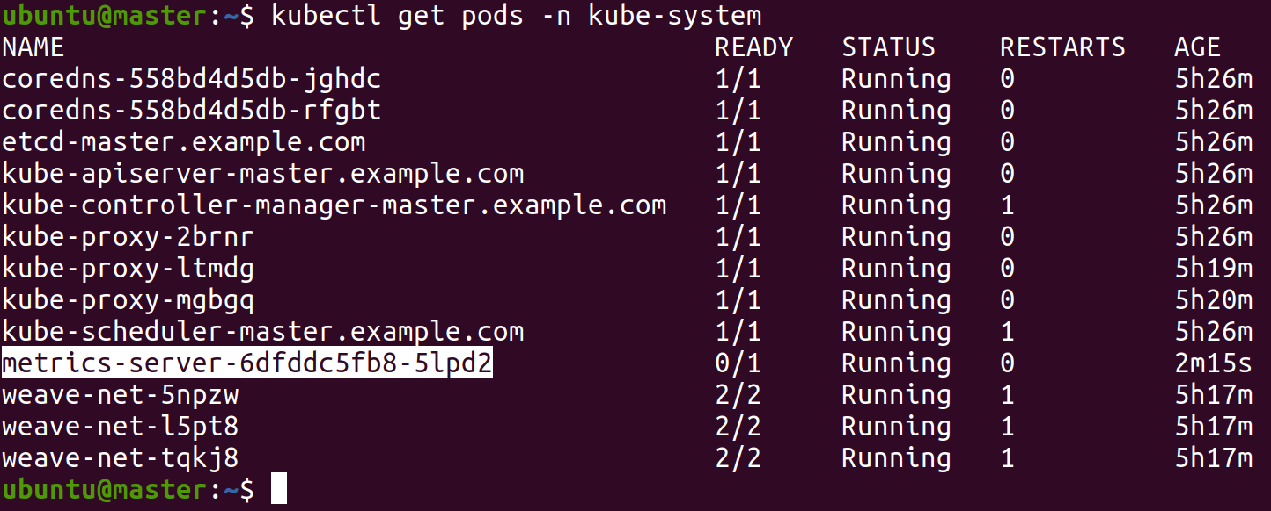

## Wget patch of metrics server

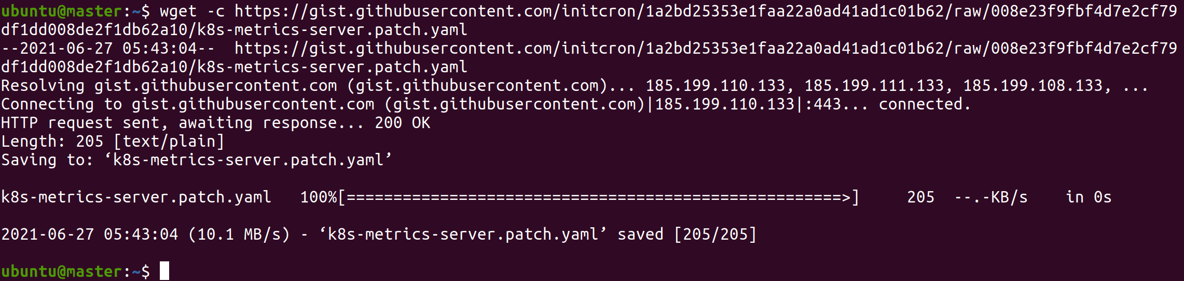

## Applying patch



## Demonstrating top node and top pods

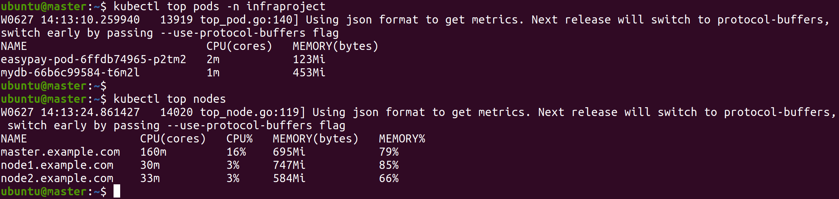

## Creating HPA Deployment

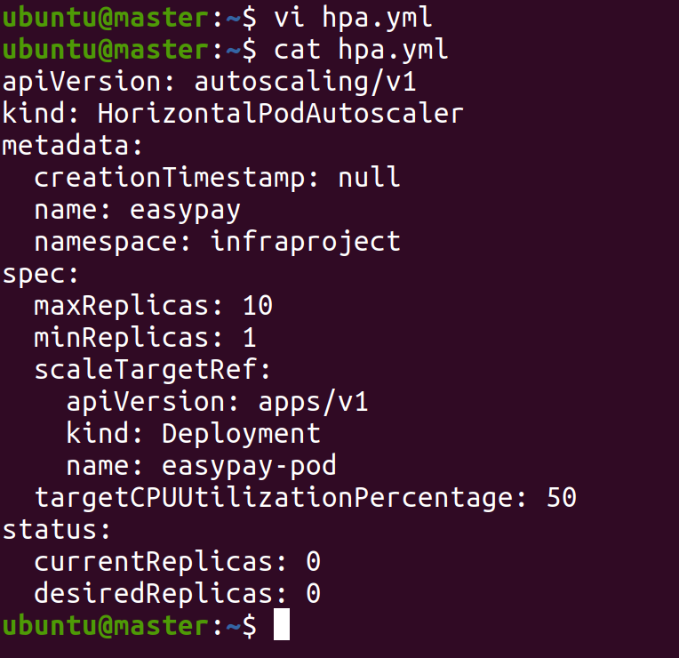

## Showing Pods in infraproject namespace before increasing load

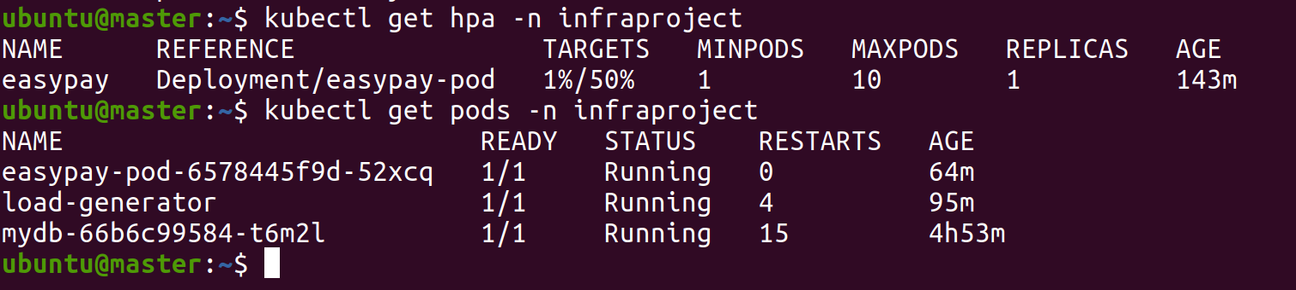

## Increasing Load on Node



## Showing pods in infraproject

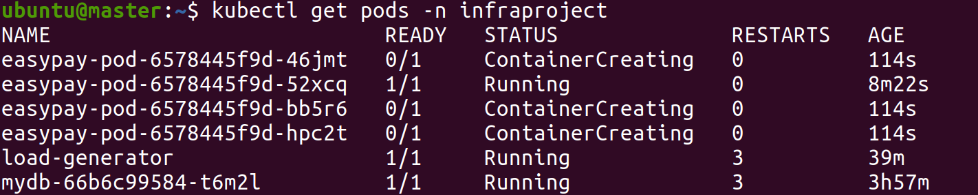

## Showing HPA target

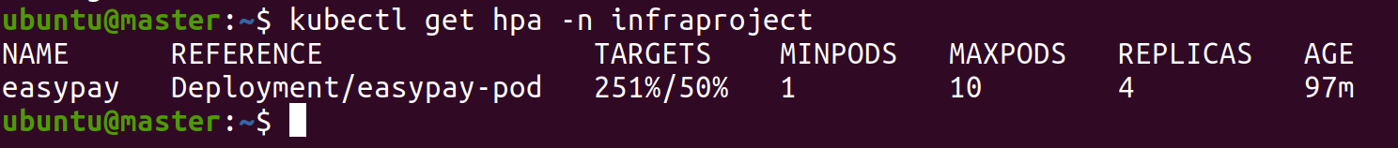

## Showing top pods & top nodes

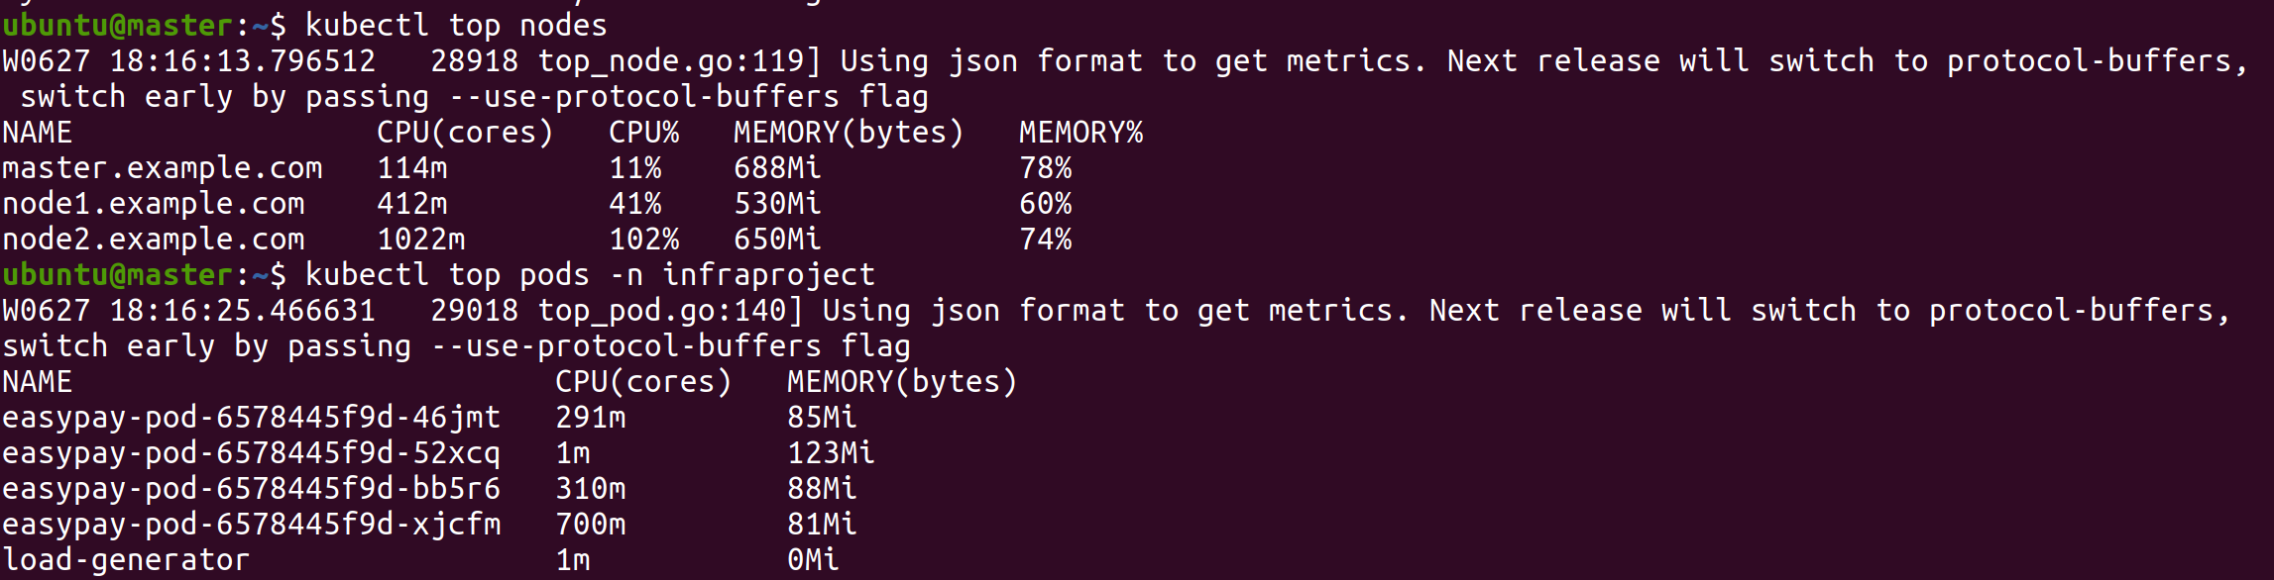

## Stopping load-generator

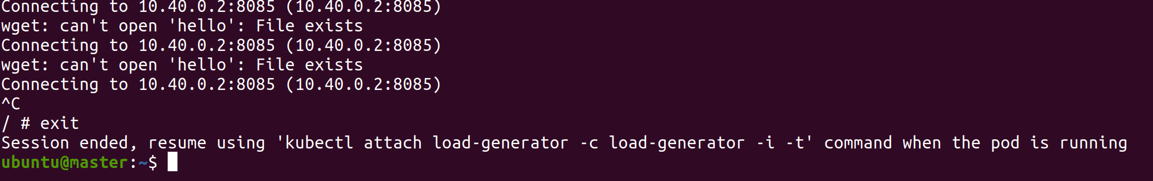

## Showing pods and HPA in infraproject namespace to see replicas scaled down after stopping load-generator



## Showing top pods in infraproject and top nodes again after stopping the load generator

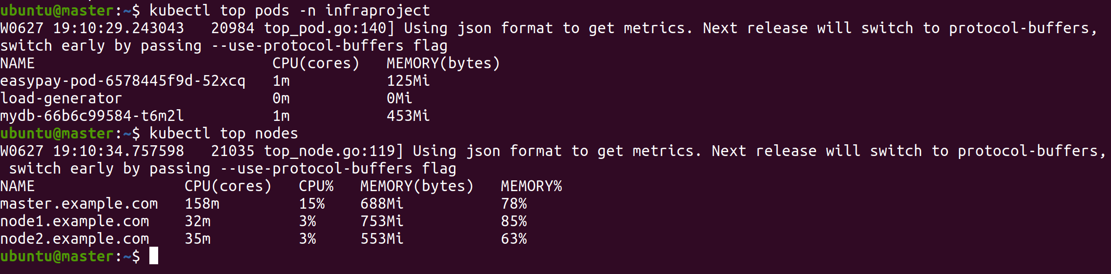

# Snapshot of the ECTD database

## List of commands run to get ETCD installed and configured to be able to take snapshot

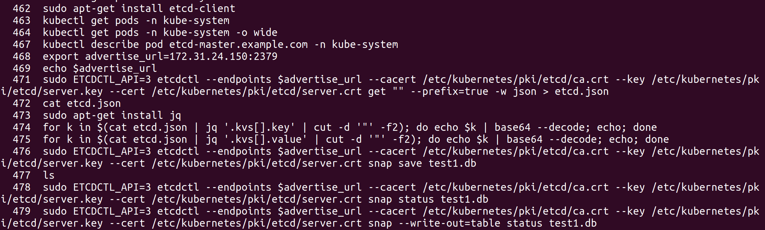

## Showing ETCD database Snapshot

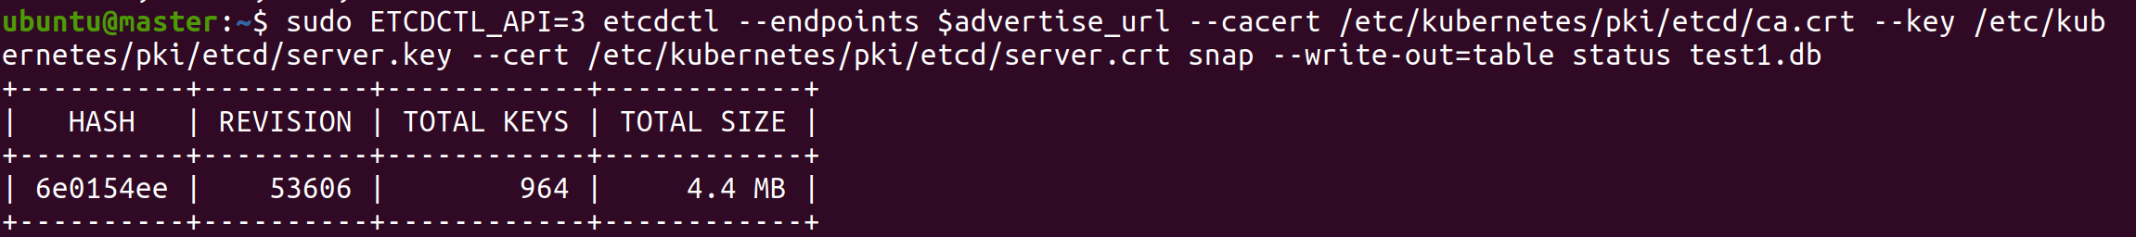

# Submitting Project to GitHub

## Creating GitHub repository

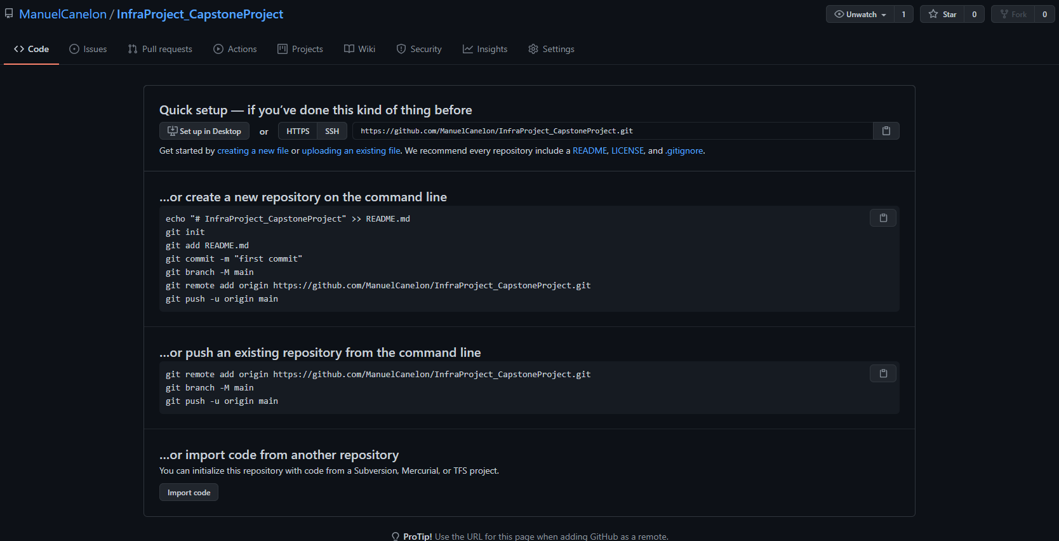

## Git init in project root directory



## Adding all files and making first commit

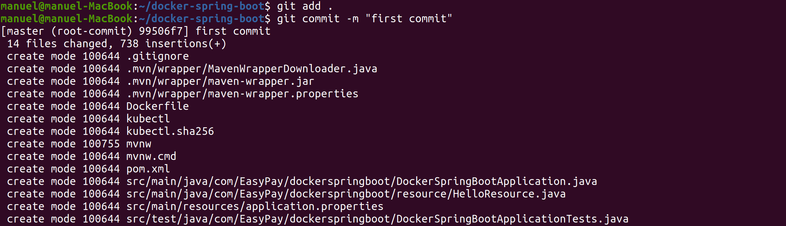

## Adding origin and pushing files to GitHub directory

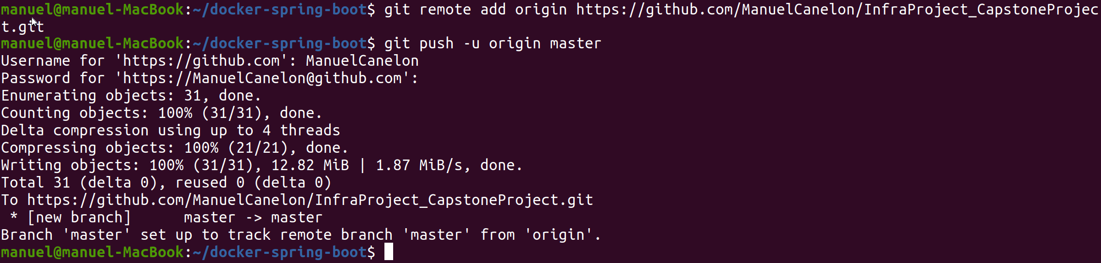

## Showing files in GitHub repository

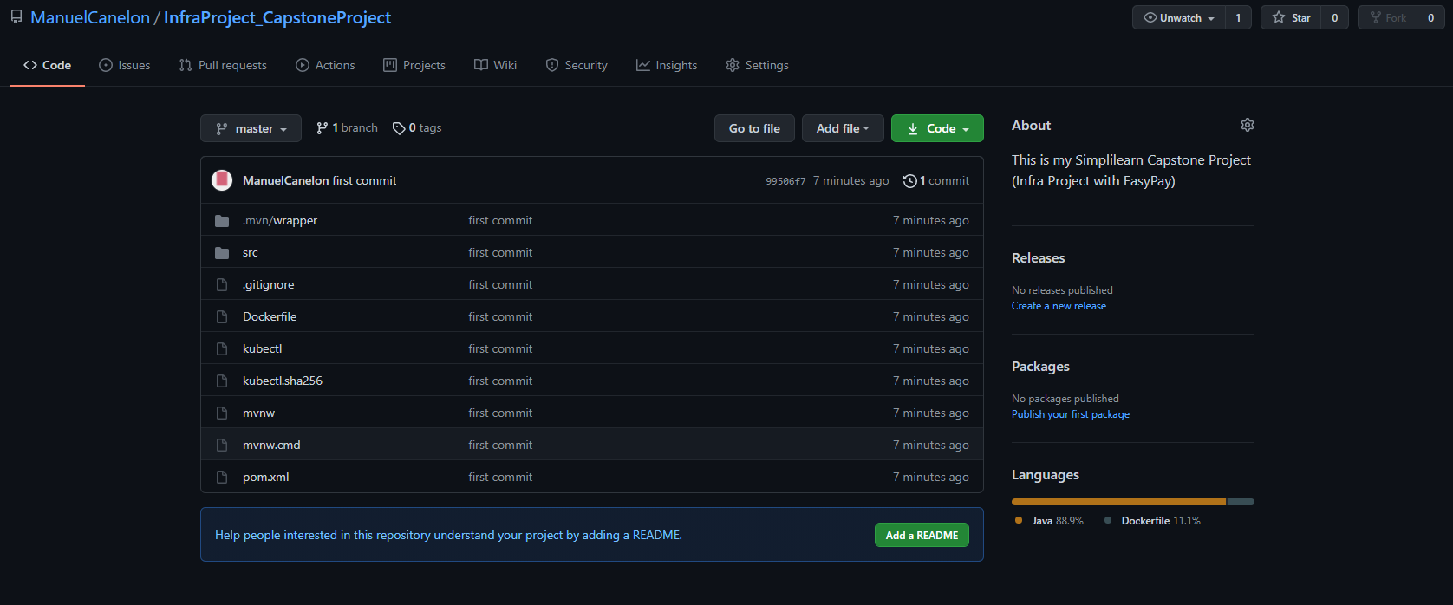

## GitHub Link

https://github.com/ManuelCanelon/InfraProject_CapstoneProject

# Project and Tester Details

This project was creating using a Spring IO Initializer sample project.

The project includes a simple Java application, **DockerSpringBootApplication.java**, found in **docker-spring-boot/src/main/java/com/EasyPay/dockerspringboot.**

The project also includes an additional Java file that I created, **HelloResource.java**, to increase load and to print “Hello from EasyPay. CPU Load was increased”, found in **docker-spring-boot/src/main/java/com/EasyPay/dockerspringboot/resource**.

The Spring IO Initializr sample project came with simple tests cases in the form of a Java application, **DockerSpringBootApplicationTests.java**, found in **docker-spring-boot/src/test/java/com/EasyPay/dockerspringboot.**

## Original simple Java application from Spring IO Initializer, **DockerSpringBootApplication.java**, found in docker-spring-boot/src/main/java/com/EasyPay/dockerspringboot

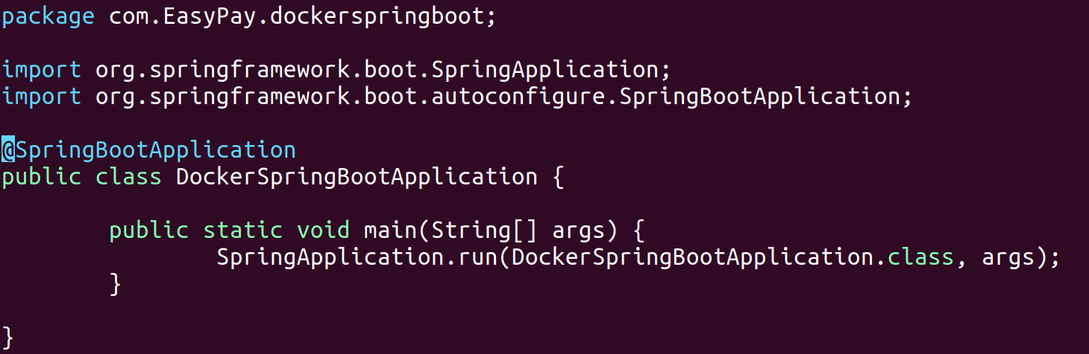

## Newly added file, **HelloResource.java**, found in docker-spring-boot/src/main/java/com/EasyPay/dockerspringboot/resource

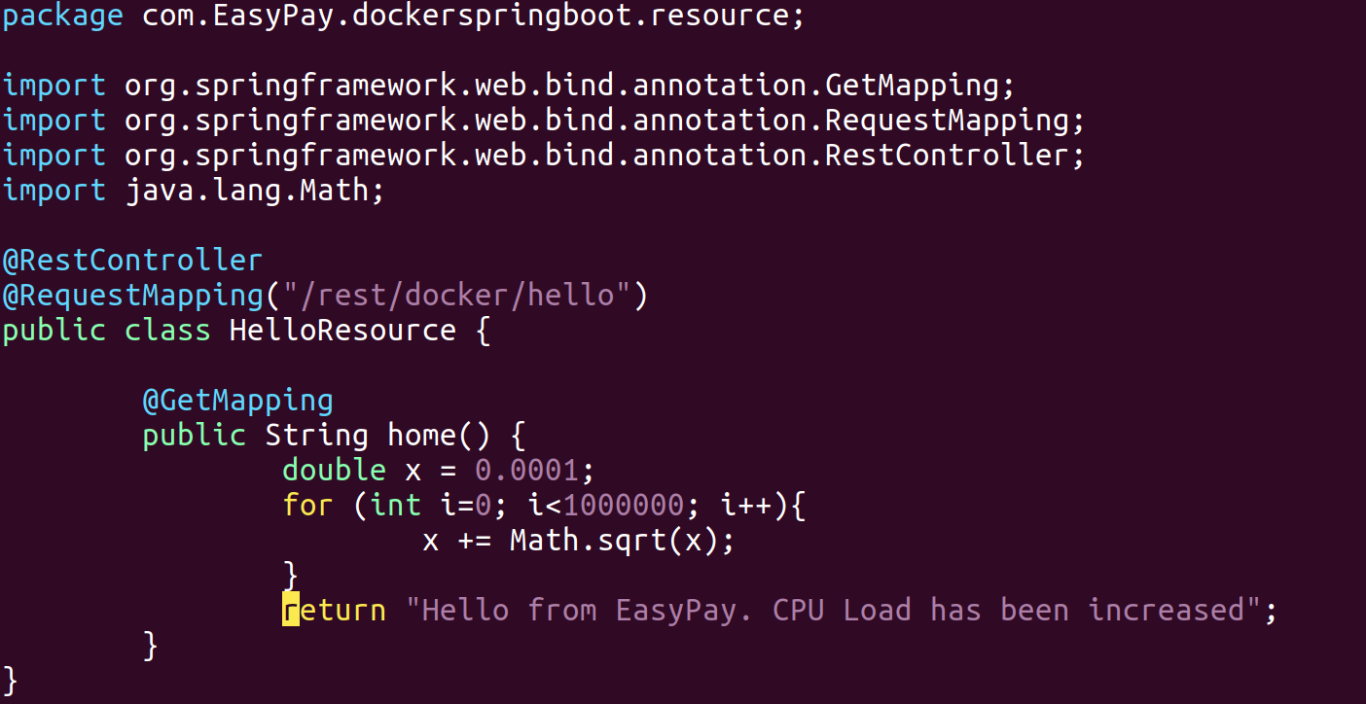

## Tester Java file, **DockerSpringBootApplicationTests.java**, found in docker-spring-boot/src/test/java/com/EasyPay/dockerspringboot

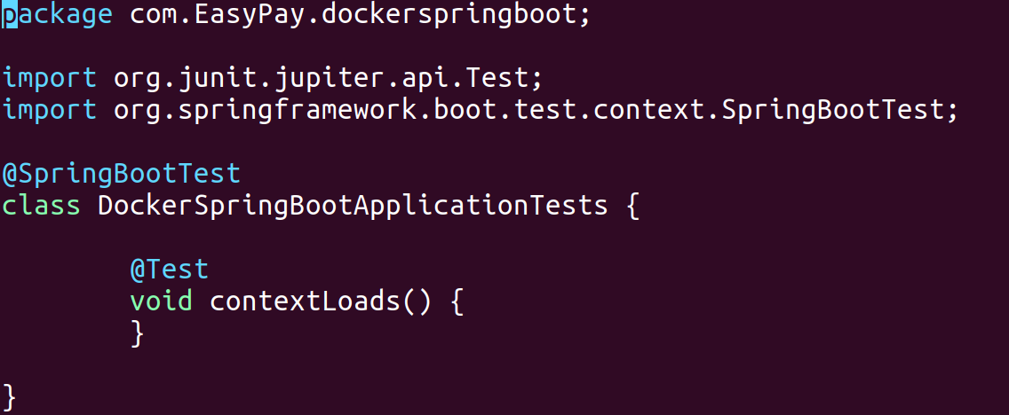

# Concepts User in the Project

In this project the following concepts were used:

* Implementation of DevOps pracites:
  + Creating a full cycle of App Development, Testing criteria, Configuration Management, AWS DevOps tools, Containerization, Container Orchestration, Agile Methodologies.
* Configuration Management with Ansible
  + Utilized by creating an Ansible-Playbook to generate EC2 Instances.
* Containerization with Docker
  + Creating Dockerfile and Docker Image to upload to DockerHub to host the EasyPay application.
* Container Orchestration with Kubernetes
  + Creating Kubernetes cluster to run EasyPay application as a Deployment.
  + Creating a Kubernetes Deployment running mysql database image from Dockerhub.
  + Connecting the mysql database and front-end application (EasyPay) using Ingress network policy.
  + Creating manuel user to create, list, get, update, patch and delete pods creating role and role binding.
  + Creating a Horizontal Pod Autoscaler to automatically scale up the application if CPU Utilization exceeds 50%.
  + Getting and saving a snapshot of the ECTD database.
* AWS DevOps Tool
  + IAM User to allow EC2 Instance creation saving the EC2 IAM credentials with boto.
  + EC2 Instances used to run Docker & Kubernetes.
  + Elastic IP Addresses used to make sure the IP Addresses of the EC2 instances are static and maintain the application stable.
  + Load Balancer to have a default/single IP Address to access the applications while the Load Balancer determines to which nodes it should send requests based on traffic and lowest resource utilization. This is a common practice for popular applications.

# Conclusion on Enhancing the Application and defining the Unique Selling Points

By performing all the steps described in detail in this project write up we have successfully implemented the EasyPay application in a high availability mode to provide the most stable and reactive environment for running the application.

Some of the unique selling points of this project are:

* High Availability
  + By having a Deployment the application can go down or a node can go down killing the pod running, and the Deployment will trigger a new pod on the next available node. Always making sure that the minimum number of replicas are running, as per defined in EasyPay Deployment yml file.
* Containerized Application
  + Running a containerized application provides the same environment over and over, avoiding running into issues often found when running the application in different environments (dev, test, prod). A containerized application guarantees the application will constantly run under the same conditions.
* Automation
  + Hosting the application as a deployment in a Kubernetes cluster minimizes the amount of human intervention required in case of potential issues.
* Easiness to update and roll back Application
  + Applications can be easily upgraded without the need of a downtime. Also, in the case the new updates cause issues, the application can also easily be rolled back without downtime or very minimal downtime (depending on setup).